Business analysis
Business analysis always begins by helping to determine and define what a
problem or opportunity might look like and identifying associated business
needs. From here, business analysts can then identify and recommend viable
solutions that meet these needs.
They can craft these requirements and suggestions for improvements based on analysis that they undertake and various conversations that they might have with stakeholders to fully define not
Only where we might be now, but what we might foresee and envision for the future. Eliciting,
documenting, and managing these sorts of stakeholder requirements to meet business and project objectives are critical.
This is how we ensure that the efforts that we undertake remain aligned with those underlying needs and that we actually solve a problem or help to meet an opportunity that creates value for the organization.
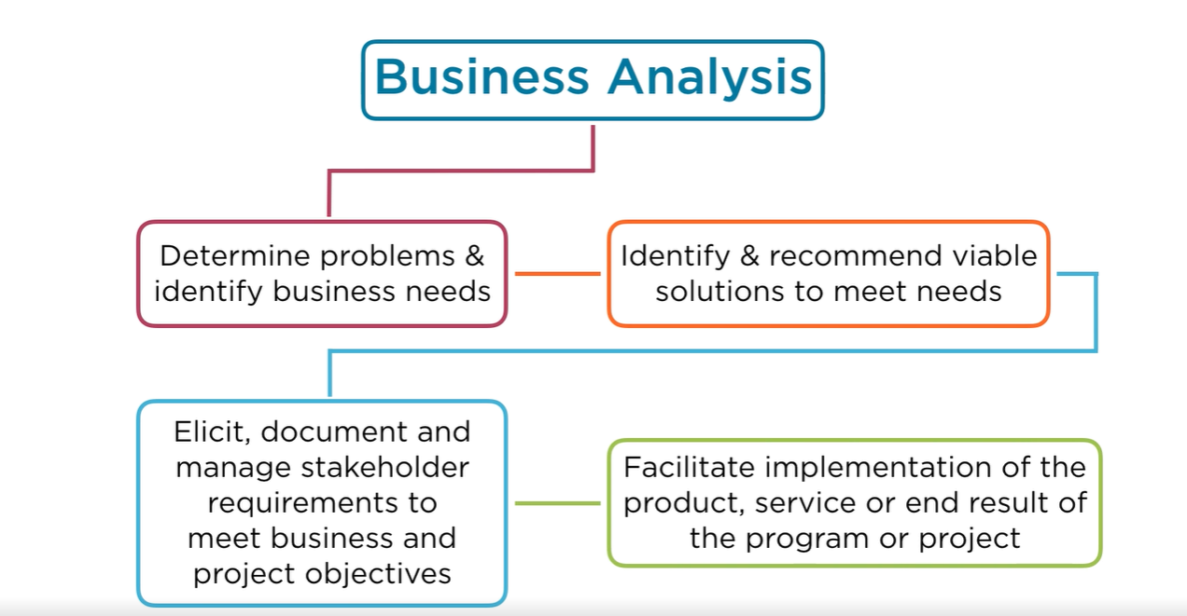
From here, business analysts continue their work helping to facilitate the implementation of the product, service, or end result of the program or project.
Here, business analysts may not always be directly in charge of the efforts once they're underway, but rather can serve as one of the guiding visionaries for what the project should be able to achieve.
Business analysis efforts are not always conducted by those who are known purely by the title of business analyst.
While there are, of course, full-time business analysts who are exclusively focused on the discovery and analysis of information, investigating stakeholder needs, and determining underlying issues and identifying opportunities, part-time business analysts also exist within
many organizations conduct business analysis in addition to other responsibilities.

Some of the titles that might be given to those who conduct business analysis on a part-time basis include business architect, business system analyst, enterprise analyst. systems analyst,
process analyst, as well as product or project manager and requirements engineer.
In these cases, their duties may exceed the mandate of an individual business analyst where we might not just create and define what our requirements might be, but also as a product or project manager, for example, be responsible for executing on these requirements and ensuring that this work is done.
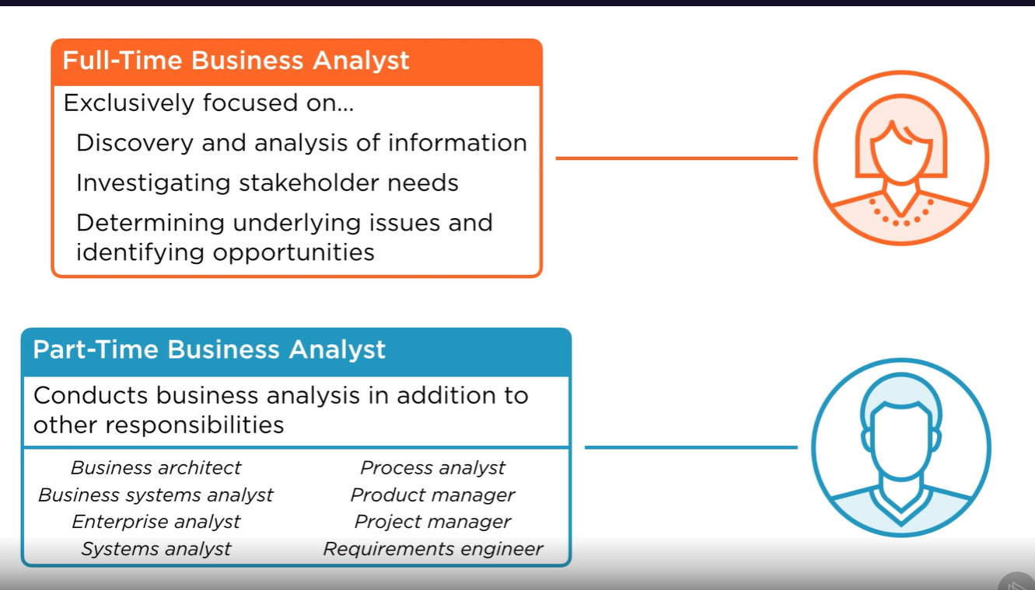
In any case, if you're a full-time business analyst, it's important for you to work closely with other stakeholders who will be involved in actually deploying the solutions that you are able to define, recommend and see passed through those stakeholders with decision-making authority within the organization.
As the keeper of this original knowledge, no one has a better understanding of the present state of the organization and where you'd like to go moving forward. In conducting business analysis, a number of key activities will be found throughout our efforts regardless of the type of project or initiative that we might be assisting with.
First, we begin by assessing the organization's needs and what opportunities we might foresee for change to help drive value for the organization.
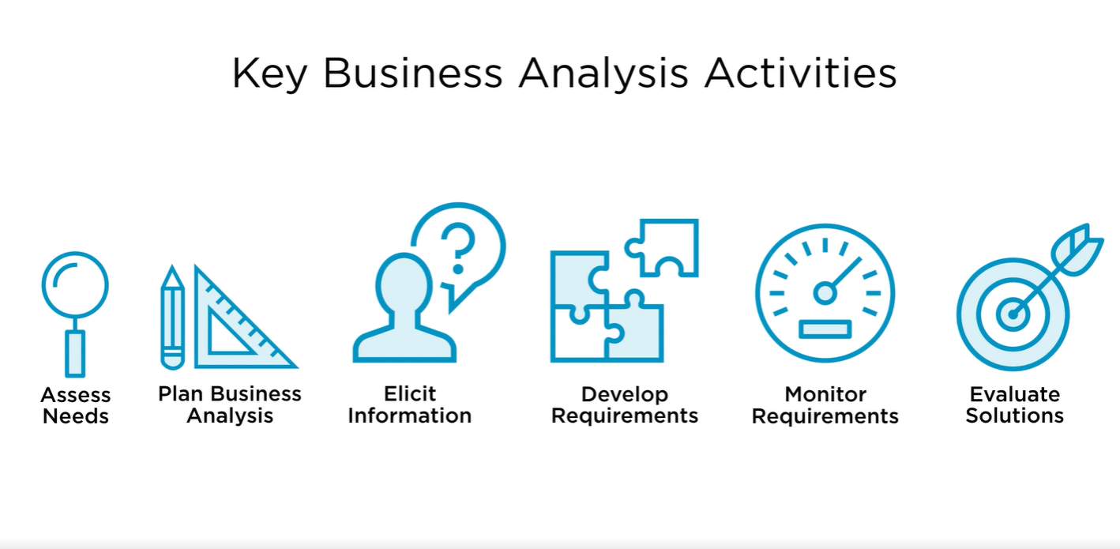
From there, we plan out our business analysis activities and how we'll go about eliciting information from stakeholders. We also obviously conduct these elicitation sessions and use that
information both from interviews and conversations we have with stakeholders, as well as the analysis of data sources and other information we have access to develop our requirements for action.
These requirements, if completed, help us to fulfill the needs that we've initially assessed and
identified. From here, monitoring requirements allows us to ensure that they continue to define actions that actually will allow us to meet those underlying needs.
It's important for us to continue this process rather than locking in the definition of a requirement and never assessing it again because so many different factors can continue to change.
Stakeholder preferences might shift over time, or changes in the competitive landscape might also cause us to reassess what our actual needs might be and how we might best be able to fulfill them.
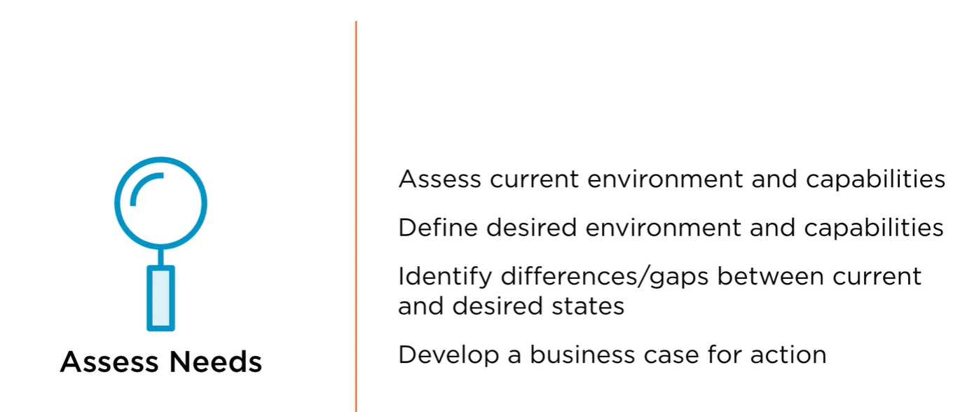
Finally, we have to evaluate our solutions as well to ensure that what we've created
actually generates the value that we had initially foreseen. This also helps us in our continuous improvement efforts. And if we evaluate our solutions incrementally as project work continues,
it can allow us to make corrective actions along the way. Let's look at each of these a bit closer. When it comes to assessing needs, we not only look at what might be internal to the organization, but also many of the environmental factors that might be driving
either problems or opportunities for our organization. We define what our desired environment and capabilities might look like in the future and what differences and gaps there might be between these current and desired states. From here, we can develop a business case for action to take place.
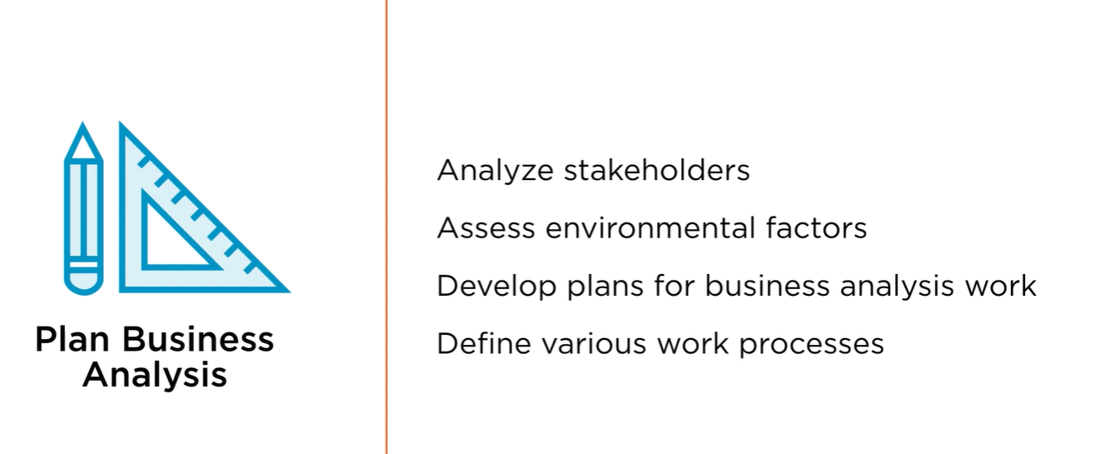
In some cases, we may wish for something to ideally be different in some capacity, but if it would not actually drive sufficient value to make it either achievable or worthwhile for us to undertake, then this is something that we should simply keep in mind and reassess in the future.
On the other hand, those changes that we can justify because the value clearly outpaces the cost in some respect, whether it be helping us to make more money or some sort of strategic benefit to the organization, these are ones that we can craft a business case for action. From here, we can plan out our business analysis activities, analyzing stakeholders, assessing environmental factors that might be at play, as well as developing plans for our business analysis work, and defining our various work processes.
Here, you can see already the inner relationship that exists between each of these key tasks. In order for us to fully assess our needs, we'll need to be able to have spoken with some stakeholders. To do this, we have to analyze to understand who our stakeholders might be and what might be valuable to them and how they might be related to the change initiative that we're considering. Similarly, while we might be assessing environmental factors here, we'll continue to do so throughout many of these other capacities as well. This provides us a framework for our actions to take place and is something that we can continue to tailor and refine as our efforts
continue.
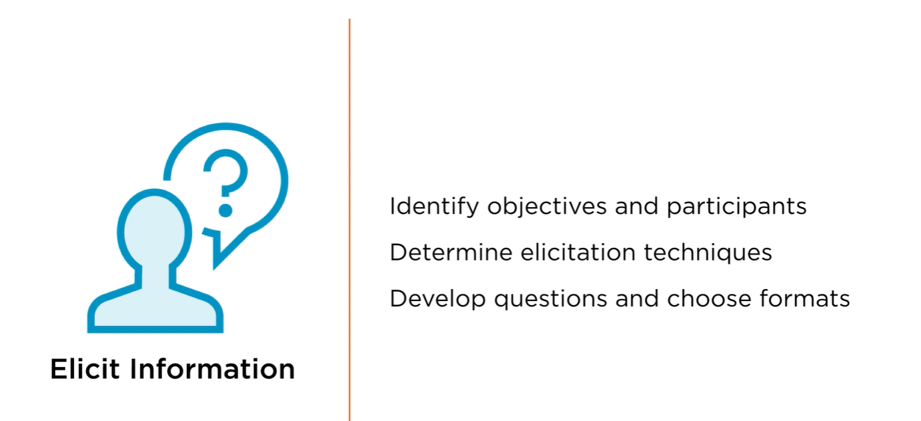
Eliciting information comes next. This is perhaps the most critical role for any business analyst,
allowing us to gain an understanding based on the composite perspectives of many stakeholders and data sources and information we have available to us in order to generate an idea of the present state and what our desired future capabilities might look like. In order to elicit information, we begin by identifying our objectives for each elicitation session and who our
participants should be.
What are we trying to learn?
Is this meant to be purely exploratory in nature?
Or do we already have a specific topic in mind that we wish to discuss
with a subject matter expert? In each of these cases, we might craft
very different sessions, in one using an interview, in another using
perhaps a workshop. Or if we have something we'd like them to evaluate
as a potential solution, perhaps a focus group would make more sense.
We have a variety of different tools at our disposal. Determining these
elicitation techniques can help us to best use our stakeholders and our time
effectively and to ensure that we gain a maximum number of insights that we
can bake into our overall approach to crafting our solution. Developing
questions and choosing formats for these elicitation sessions in advance can
help to make sure that we make the most of each of these opportunities, and
applying the same sort of rigor to the efforts we might undertake on our own
as analysts, either looking at data sources or other types of information,
can also help us to better use our stakeholders' time effectively and
paint a broader picture of the overall landscape.
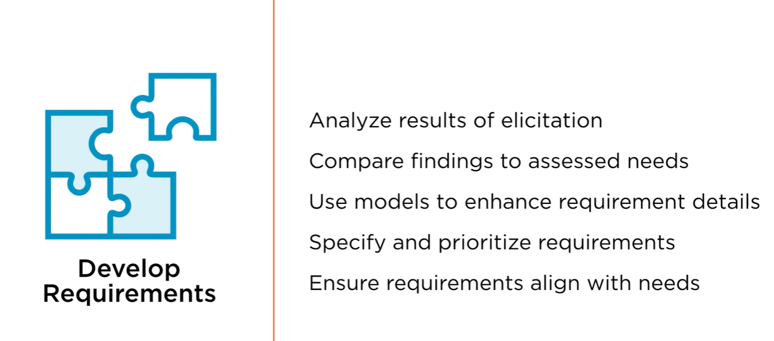
Developing requirements is the result of analyzing our elicitation efforts. Comparing our findings in elicitation to the needs that we've assessed along the way, we can confirm where action should be taking place based not only on our perspective, but also the shared perspective of the many stakeholders we work with.
Using models in order to enhance these requirement details can be helpful as we can move past the purely theoretical into a more exacting understanding of what precisely a solution might look like. Not just envisioning a fuzzy change, but rather an actual detailed solution that can help us to meet that need. Specifying and prioritizing these requirements is important in any business analysis environment, but especially in those that are more agile in nature.
Being able to prioritize requirements means that we can deliver
the most value to stakeholders more quickly,
putting pieces or components of our solution into place before the entire
thing is necessarily completed, gaining valuable information that can drive
our future work, and help to immediately provide a return to the
stakeholders that we've worked with. Continuing to ensure that requirements
align with needs is something that should take place not only as part of
developing our requirements,
where we immediately confirm that they in fact align
directly with an underlying need,
but, of course, is a key driver to monitoring our requirements as well.
Using traceability methods can help us to understand exactly what core
principles or objectives each requirement helps to fulfill and why
we're spending time developing them. Measuring requirements
performance helps us to ensure that the requirement, as defined, has
been completed successfully and that by doing so we actually have met
that underlying need.
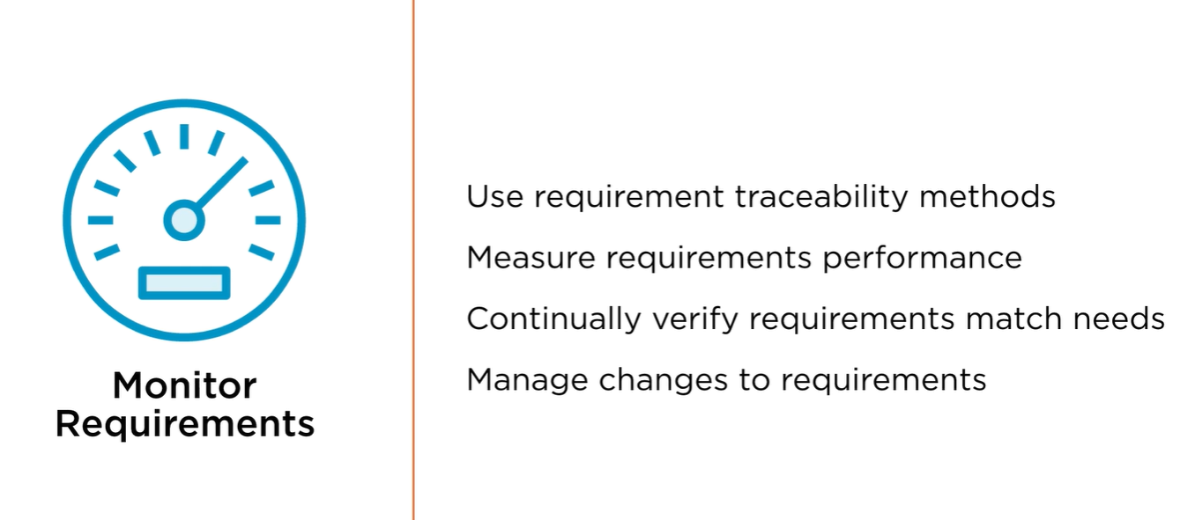
It could be that we are absolutely certain all the way through
implementation that going down a certain path is the best way to
meet an underlying need for the business.
But once we've created that solution,
it simply doesn't work the way that we anticipated that it would or doesn't
drive the value or gains in efficiency that we might have anticipated due
to factors that we simply had not foreseen.
Being honest about this means setting measurement criteria in advance so that we
can be objective in our measurement of success or failure and retool our efforts
to ensure that we eventually are able to create the value that we had initially
anticipated. Continually verifying that requirements match up with needs is part
of this monitoring process,
but also incumbent on us is to manage changes to requirements as they emerge.
This too is particularly valuable in agile environments where we might be
rapidly learning more information as our work continues that causes us to
want to retool our requirements to better align with needs as our
understanding of them continues to evolve.

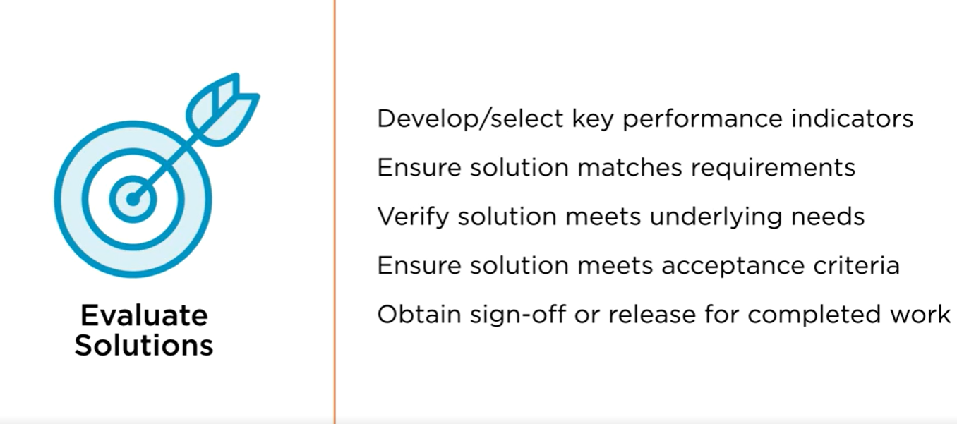
Finally,
when it comes to evaluating solutions, developing and selecting key performance
indicators allows us to have that objective point of measurement. Ensuring that
our solutions match requirements and that our requirements match our underlying
needs provides that straight line of accountability and traceability that
ensures that every action we take helps to drive value for the organization.
Verifying that solutions meet underlying needs once they've been completed
empowers us to ensure that our work has been successful. Verifying that
solutions meet underlying needs is critical because otherwise the work that
we've been doing is all for naught. Just as important though is ensuring that
solutions meet acceptance criteria as they've been defined.
If we've been able to create a solution that drives value, but not
in the way that was anticipated and agreed upon,
this is likely to raise issues with various stakeholders that might need
to still be addressed. Obtaining sign-off or release for completed work
is what eventually brings our work on this change initiative to a
completion. And without meeting the underlying goals, in doing so in a
way that's been agreed to,
it's unlikely that we'll be able to consider this effort complete and move on to new ways to drive value for the organization
Au
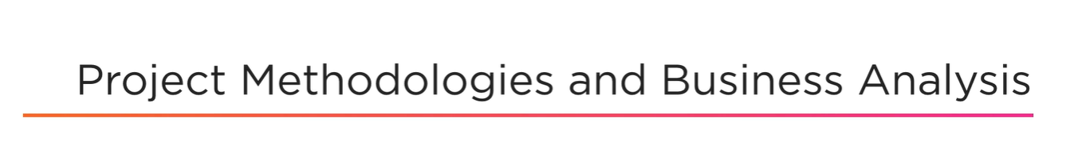
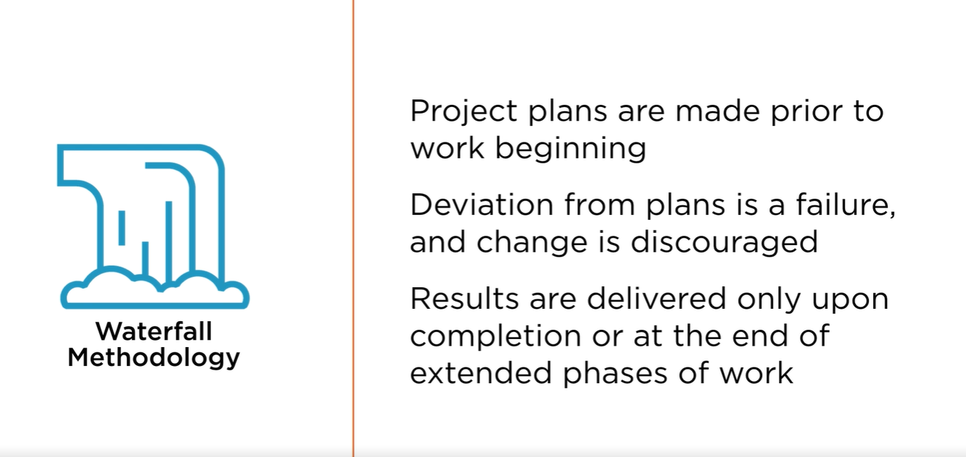
There are many ways to approach project management in an effective manner,
but understanding where your project or your organization might
fall on this particular spectrum can be vital in helping to
develop your approach to business analysis.
On one end of this extreme perspective,
we have what might be known as a purely waterfall methodology,
and on the other, a purely agile methodology.
When it comes to waterfall, in an ideal environment,
project plans are completely created prior to work beginning.
Deviation from these plans is considered a type of failure because we
weren't able to adequately anticipate all of the various environmental
factors that might have caused changes such that we can incorporate them
into our original plans from the outset.
Change is discouraged in waterfall environments because we should
have spent more time and resources on planning effectively such that
we could immediately execute on our plan without interruption in the
most efficient way possible.
Results are delivered only upon the completion of all project work or at the
end of extended phases of work that have also been previously defined based on
the objectives that might be associated with them.
In an ideal world, waterfall projects can be very efficient in nature,
delivering on time and on schedule so long as we ignore all of
those pesky real-world environmental factors.
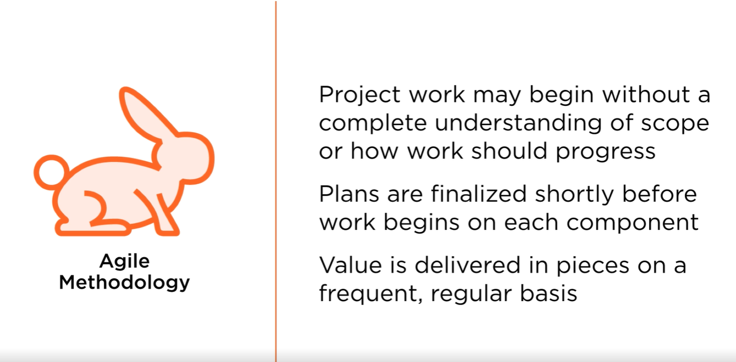
Agile, on the other hand,
is meant to address these by being much more
improvisatory in nature and allowing us to adapt,
in other words, be faster and, you guessed it,
more agile in our approach.
Project work may begin without even having a complete understanding of what
the project scope might be or how work should progress.
This is ideal in situations where so many unknown factors
exist that we can't even pretend to put together a plan that
would be entirely comprehensive.
Rather,
this allows us to begin to experiment and do the sort of
reconnaissance necessary to understand where value might exist,
to try certain approaches for a period of time,
see if they pay off, and if not, adjust our efforts to go in a new direction.
Plans are finalized shortly before work begins on each component of the project,
and the way that we divide up the work in an agile environment allows
us to deliver value to stakeholders on an ongoing,
regular basis.
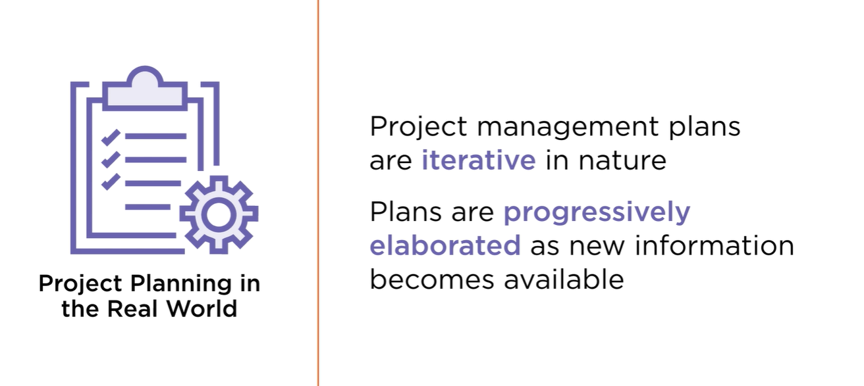
You can see why this might have appealed in the software development
environment first before beginning to expand into other areas,
because it was easier to split software up on a feature-by-feature basis
and release various versions pretty quickly over time,
delivering incremental value until we could get to a
point that we defined as complete.
In fact, this value is delivered in pieces on a frequent and regular basis,
not tied to specific objectives, but rather to a certain increment of time.
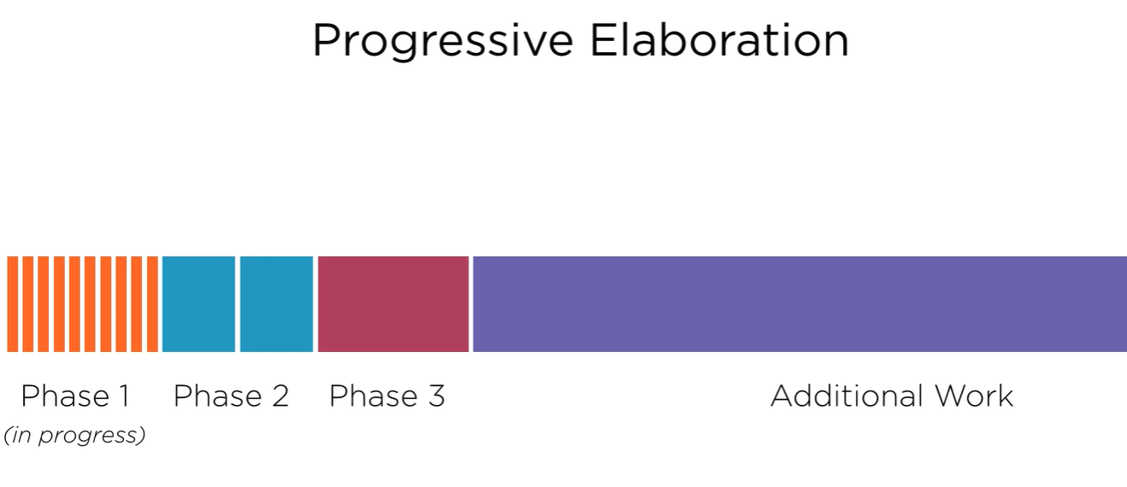
Every two weeks, for example,
there's an expectation that we should be able to
deliver something of functioning value.
Even if it's relatively small in nature,
even if it only helps to build a foundation for larger
value features that may come later,
we should expect to complete a certain piece of our work in
its entirety within this period of time.
If we find that to be impossible,
it's likely that we simply have not decomposed our requirements far
enough to understand what subset of that requirement could be
completed and could offer value to us right away.
Of course, in the real world,
neither of these approaches is typically purely followed,
but rather, project plans fall somewhere in between.
Your team may be more predictive following a waterfall approach of
planning very rigorously upfront or more agile in nature,
seeking to improvise, learn quickly, fail fast,
and pivot into a new direction.
In any case, project plans are all iterative in nature.
We revise them over time.
Even our best laid plans in a purely waterfall environment will be
subject to changes as there will inevitably be some factors that we
were not able to consider appropriately.
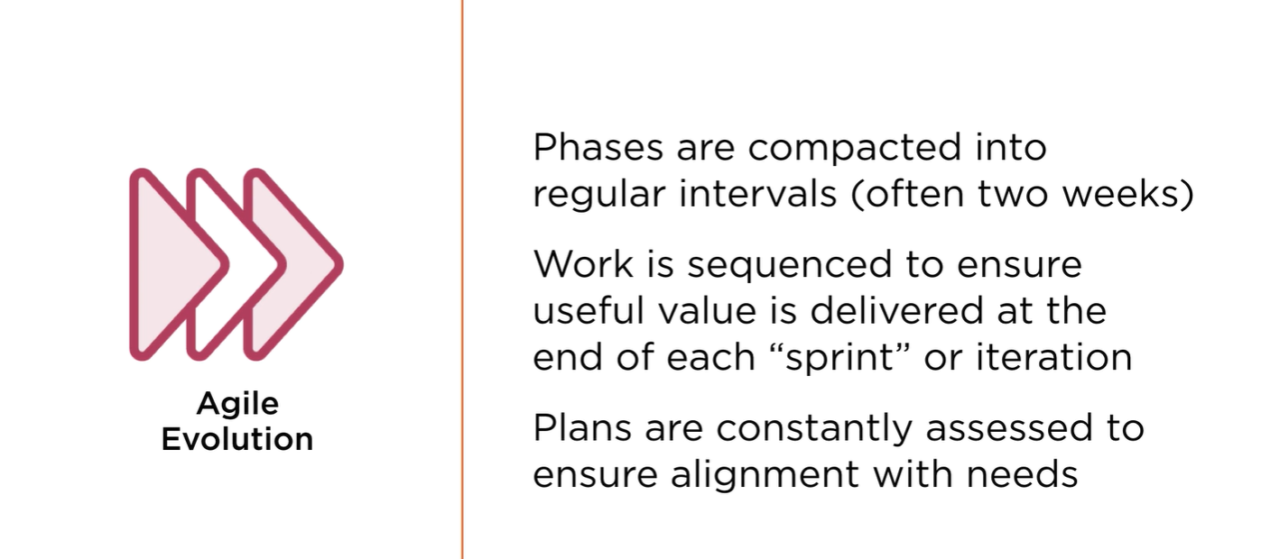
In Agile,
we embrace this approach and know that we'll be constantly revising our plans,
but in any case, we'll have some plans,
and then we'll go back and make changes to them over time.
Part of this process is also progressively elaborating on these
plans as new information becomes available.
This is an approach that has always existed in waterfall environments and is
simply accentuated in today's new agile thinking world.
Progressive elaboration involves having a very clear and meticulous
understanding of the work that we're about to undertake and then a less
clear idea of what future work might look like,
knowing that we'll be able to either build on the new knowledge that
we've developed during the work that we're doing now or simply have more
time and visibility to define our plans more appropriately for future
phases when we get closer to them.
H re, for example,
we know that in phase 1 we have a very clear
understanding of all of the work to be completed.
In phase 2, we have a somewhat clear idea of how we might break that work up,
but not all of the detail is set in stone just yet.
Phase 3 might encompass a variety of objectives we
know that we'd like to complete,
but we don't have any precise plans for how that will be accomplished.
And then past that are a variety of other requirements that we'd like to
fulfill that we haven't even broken into phases yet.
In a progressive elaboration environment,
as we complete phase 1, we begin to shift this forward,
now having a very clear understanding of phase 2,
a better idea of phase 3, and defining out a new phase 4,
helping to take out an additional chunk of that remaining
additional work for which we need to plan.
In Agile, phases are simply compacted into regular intervals,
often about two weeks in nature,
although this can flex a bit based on the needs and
realities of your project team.
Work is sequenced to ensure that useful value is delivered
at the end of each of these sprints, or iterations,
and plans are constantly assessed to ensure that
alignment with needs remains in place.
By creating our plans much closer to actually undertaking the work,
it becomes natural and easy for us to ensure that our efforts
remain aligned with our underlying needs.
We can verify that our understanding of those needs remains clear,
and then we can quickly trace back exactly how the work we're
about to do helps us to meet those needs.
This allows for a much more straightforward and clear connection
between the work that we undertake and the value we seek to create that
can be true in some project environments where plans are being followed
simply because plans are in place, even if,
for a variety of factors,
those plans no longer represent the underlying needs that they did when they were created, perhaps many months ago.


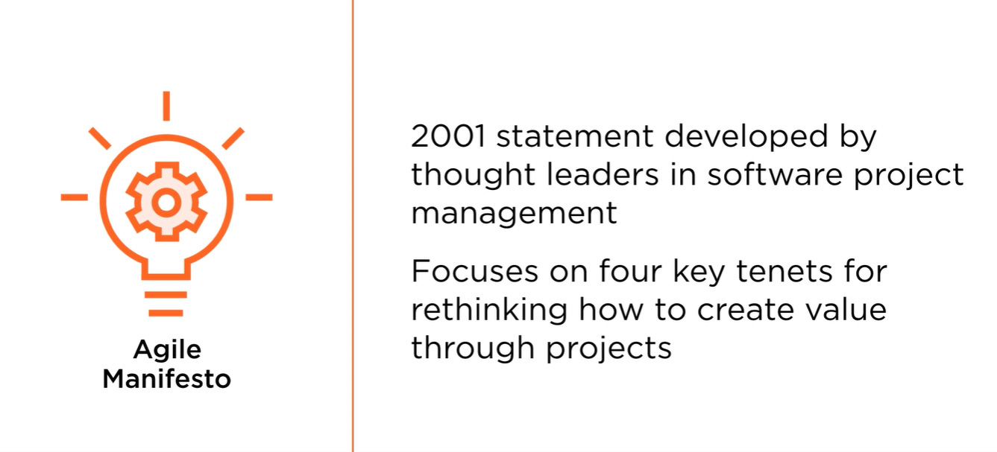
Due to a variety of factors ranging from globalization to the ever-increasing
advancement of technology, business is simply more complicated and faster moving
than it has been in past decades. This was realized by a group of individuals
who came together in 2001 to develop a statement on how they thought software
project management should change from some of the traditional project management
approaches of the past.
The Agile Manifesto focuses on four key tenants for rethinking how to create
value through projects, and we've seen that this has grown beyond its
original inception of software into being a more defining force for a
variety of industries and types of projects.
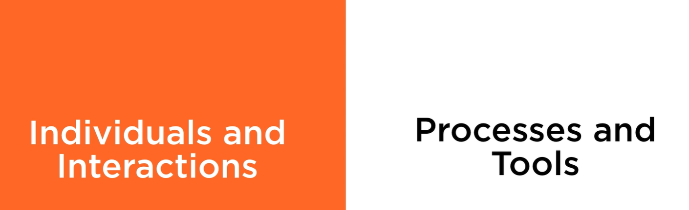
The first tenet of the Agile Manifesto,
while processes and tools are certainly of high value in
helping us to accomplish our project work,
individuals and the interactions we have with them are more important than
those processes and tools alone. Details of these processes have typically
governed the operation of project teams,
often in very rigid and strictly defined fashions,
both in terms of how work is completed and who completes each portion of work.
What the framers of the Agile Manifesto found is that nurturing more organic
relationships and work methods leads to innovations that allow us to accomplish
our work in a way that's better tailored to each individual project challenge
we might face rather than trying to simply follow processes in a blind fashion
without considering how well they actually align with the challenge that we're
seeking to surmount.
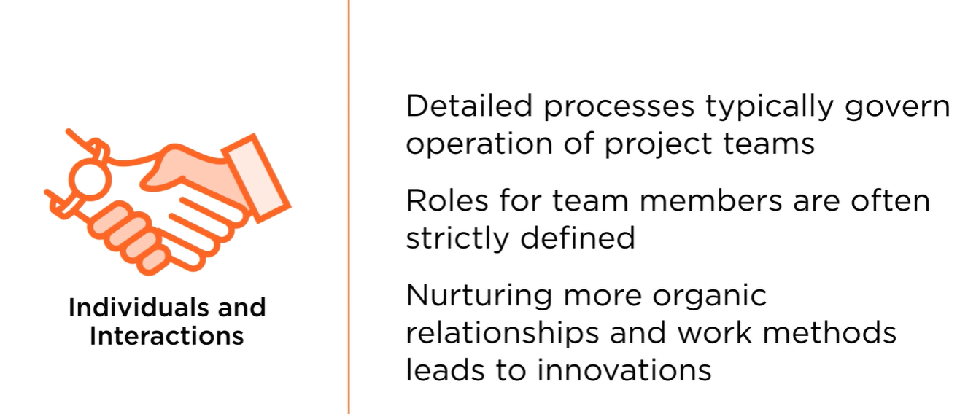
Similarly,
while comprehensive documentation is certainly a value to many
stakeholders when we're delivering a product,
having working software is even more important.
After all, we can have thousands of pages of manuals,
but if the underlying product does not perform effectively,
then what's the point? 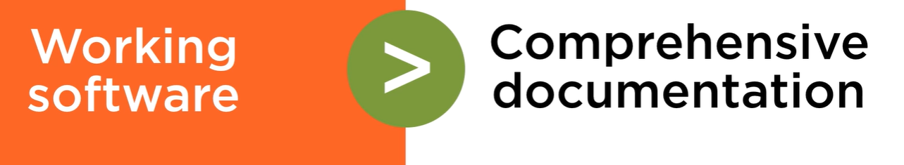
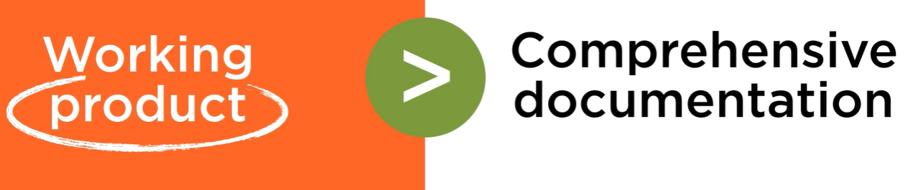
We can take this principle and actually zoom out to make it a bit broader,
looking not just at software, but rather at the definition of a working product.
This can apply to a variety of fields and help us to understand how
delivering actual tangible value is better than the metavalue that's
offered through documentation alone.
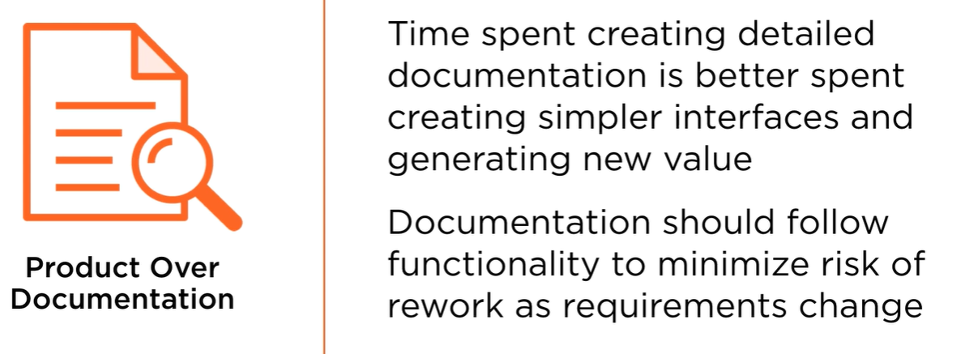
After all, time that we've spent creating detailed documentation can often
be better spent simply creating simpler interfaces and generating new
value that allows us to cut down on the amount of documentation that might
be required because we've done a better job with our work. Documentation
should follow functionality in order to minimize the risk of rework as
requirements change. Rather than creating our documentation in advance and
then trying to create solutions that match up with that, we should instead
focus first and foremost on delivering value through our actual work and
then capturing what's necessary as we are doing that work or just after
the fact in order to provide the most value.
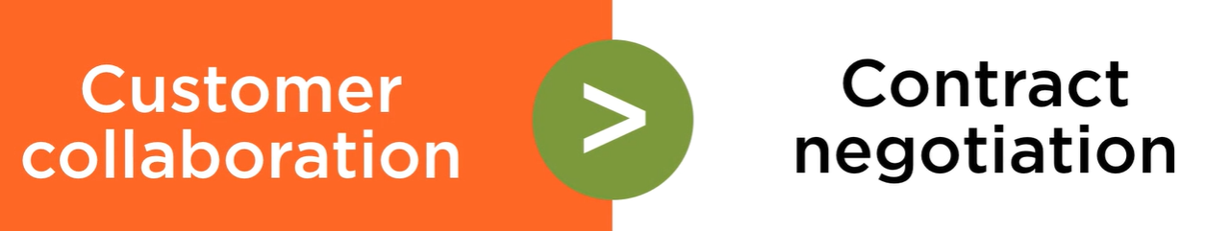
Third, between customer collaboration and contract negotiation,
we should always be more focused on the relationship that we have with the
customer. Change initiatives create value for customers,
whether they might be internal or external to the organization, and our
customers aren't always parties with which we'll have some sort of formal
contract and be receiving payment for our labor.
Rather, if we're creating a new tool internally,
then our customer would be the end users who are going to be using that
tool, as well as the sponsors who might be providing the resources
necessary to create that tool in the first place.
Having a deep and continuously updated understanding of
what offers these customers value,
whether they might be within or outside of the
organization, should drive all of our work.
An obsession with delivering this value rather than sticking to
the pure scope of what might be laid out at the beginning can
help to drive our work. And when it comes to the contracts that
we do develop between parties,
they should anticipate these kinds of changes at the outset,
making clear what sort of economic ramifications might exist as scope
might expand or contract over time based on the team's labor and the
amount of value that we are able to provide.
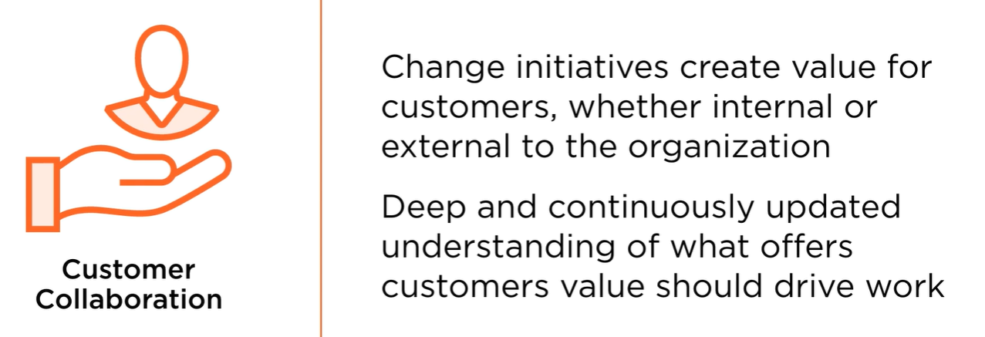
This helps us to avoid the entirely undesirable situation of arguing
over contract details when both parties might already agree that it
would be better to simply go in a different direction that was not
premeditated in that contract.
Having this encapsulated from the start helps to ensure that our
focus can be and remain in the right place.
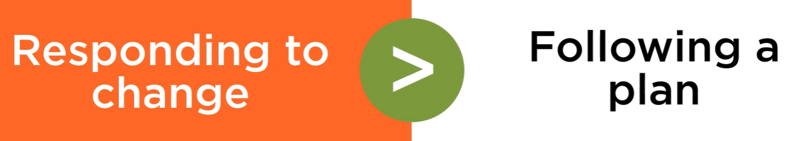
Finally, responding to change is always more important than following a plan
just for that plan's sake. Needs and environmental factors may shift
considerably during these change initiatives. After all,
the time-honored axiom that a plan only holds together
until the action begins is always true,
especially in today's ever more dynamic business environment.
Just-in-time planning can help to ensure a minimum level of wasted
work and optimal strategic alignment also exists.
Even so, we should look to continually assess whether those plans,
even if we've just made them, continue to hold up as our work proceeds.
If not, continuing to embrace change can help to ensure that we drive
that customer value that should be our obsession.
As you can see, the Agile Manifesto on its face appears to be a somewhat
radical rethinking of how project teams should produce value, but the
underlying principles here could not be any more timeless.
It's entirely about helping our customers, helping
to create value through our work,
minimizing the amount of waste that might be incurred, and ensuring
that what we create meets the values and aspirations that
originally drove our work in the first place.
These are principles that have driven project
management since its very beginning steps.
Agile is simply a new way to think about how we can recommit to
those principles and live more fully within them.
A track record of success in software development has spurred interest in
adopting these Agile principles elsewhere, and there are a set of
associated principles to this manifesto that expand on it and help to guide
efforts regardless of industry or specialty. Let's take a look at those next.

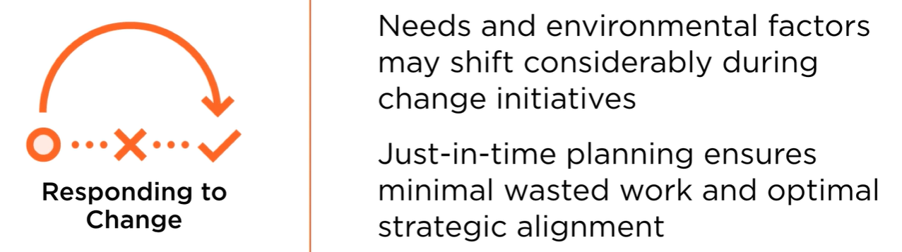

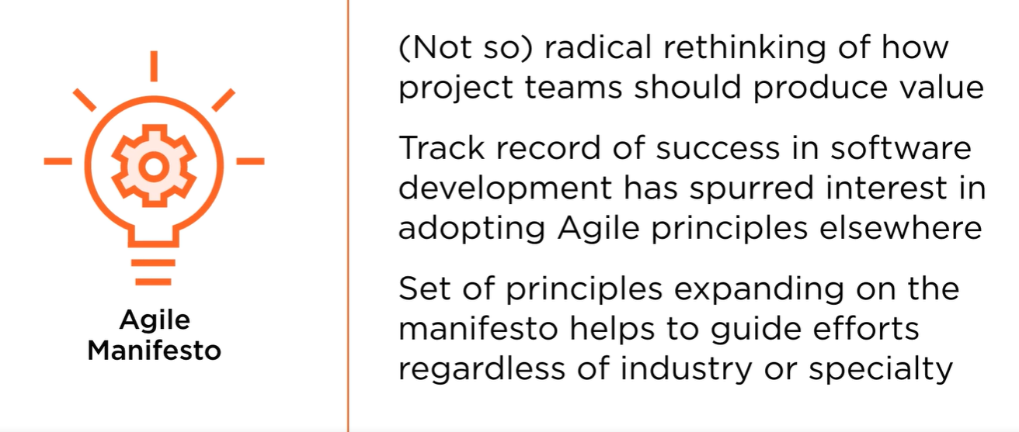
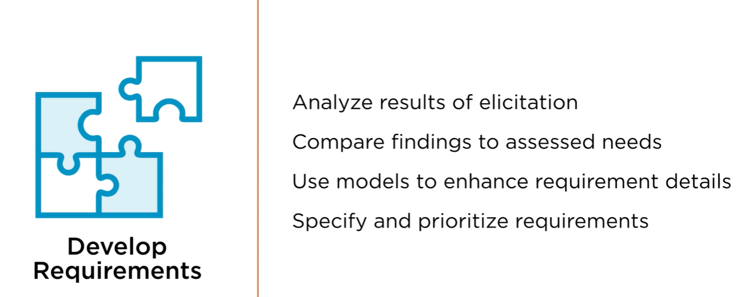
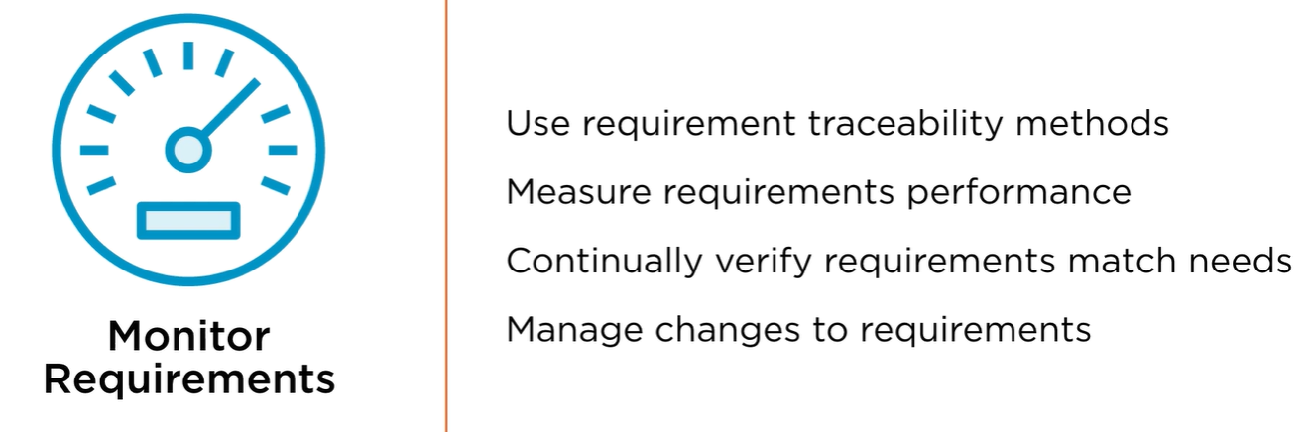
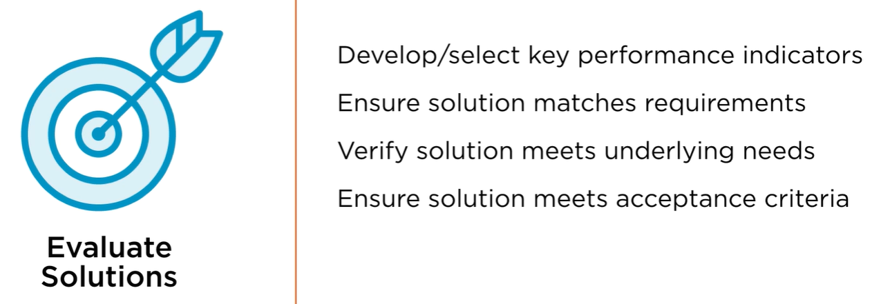

There are many ways to approach project management in an effective manner,
but understanding where your project or your organization might
fall on this particular spectrum can be vital in helping to
develop your approach to business analysis.
On one end of this extreme perspective,
we have what might be known as a purely waterfall methodology,
and on the other, a purely agile methodology.
When it comes to waterfall, in an ideal environment,
project plans are completely created prior to work beginning.
Deviation from these plans is considered a type of failure because we
weren't able to adequately anticipate all of the various environmental
factors that might have caused changes such that we can incorporate them
into our original plans from the outset.
Change is discouraged in waterfall environments because we should
have spent more time and resources on planning effectively such that
we could immediately execute on our plan without interruption in the
most efficient way possible.
Results are delivered only upon the completion of all project work or at the
end of extended phases of work that have also been previously defined based on
the objectives that might be associated with them.
In an ideal world, waterfall projects can be very efficient in nature,
delivering on time and on schedule so long as we ignore all of
those pesky real-world environmental factors.
Agile, on the other hand,
is meant to address these by being much more
improvisatory in nature and allowing us to adapt,
in other words, be faster and, you guessed it,
more agile in our approach.
Project work may begin without even having a complete understanding of what
the project scope might be or how work should progress.
This is ideal in situations where so many unknown factors
exist that we can't even pretend to put together a plan that
would be entirely comprehensive.
Rather,
this allows us to begin to experiment and do the sort of
reconnaissance necessary to understand where value might exist,
to try certain approaches for a period of time,
see if they pay off, and if not, adjust our efforts to go in a new direction.
Plans are finalized shortly before work begins on each component of the project,
and the way that we divide up the work in an agile environment allows
us to deliver value to stakeholders on an ongoing,
regular basis.
You can see why this might have appealed in the software development
environment first before beginning to expand into other areas,
because it was easier to split software up on a feature-by-feature basis
and release various versions pretty quickly over time,
delivering incremental value until we could get to a
point that we defined as complete.
In fact, this value is delivered in pieces on a frequent and regular basis,
not tied to specific objectives, but rather to a certain increment of time.
Every two weeks, for example,
there's an expectation that we should be able to
deliver something of functioning value.
Even if it's relatively small in nature,
even if it only helps to build a foundation for larger
value features that may come later,
we should expect to complete a certain piece of our work in
its entirety within this period of time.
If we find that to be impossible,
it's likely that we simply have not decomposed our requirements far
enough to understand what subset of that requirement could be
completed and could offer value to us right away.
Of course, in the real world,
neither of these approaches is typically purely followed,
but rather, project plans fall somewhere in between.
Your team may be more predictive following a waterfall approach of
planning very rigorously upfront or more agile in nature,
seeking to improvise, learn quickly, fail fast,
and pivot into a new direction.
In any case, project plans are all iterative in nature.
We revise them over time.
Even our best laid plans in a purely waterfall environment will be
subject to changes as there will inevitably be some factors that we
were not able to consider appropriately.
In Agile,
we embrace this approach and know that we'll be constantly revising our plans,
but in any case, we'll have some plans,
and then we'll go back and make changes to them over time.
Part of this process is also progressively elaborating on these
plans as new information becomes available.
This is an approach that has always existed in waterfall environments and is
simply accentuated in today's new agile thinking world.
Progressive elaboration involves having a very clear and meticulous
understanding of the work that we're about to undertake and then a less
clear idea of what future work might look like,
knowing that we'll be able to either build on the new knowledge that
we've developed during the work that we're doing now or simply have more
time and visibility to define our plans more appropriately for future
phases when we get closer to them.
H re, for example,
we know that in phase 1 we have a very clear
understanding of all of the work to be completed.
In phase 2, we have a somewhat clear idea of how we might break that work up,
but not all of the detail is set in stone just yet.
Phase 3 might encompass a variety of objectives we
know that we'd like to complete,
but we don't have any precise plans for how that will be accomplished.
And then past that are a variety of other requirements that we'd like to
fulfill that we haven't even broken into phases yet.
In a progressive elaboration environment,
as we complete phase 1, we begin to shift this forward,
now having a very clear understanding of phase 2,
a better idea of phase 3, and defining out a new phase 4,
helping to take out an additional chunk of that remaining
additional work for which we need to plan.
In Agile, phases are simply compacted into regular intervals,
often about two weeks in nature,
although this can flex a bit based on the needs and
realities of your project team.
Work is sequenced to ensure that useful value is delivered
at the end of each of these sprints, or iterations,
and plans are constantly assessed to ensure that
alignment with needs remains in place.
By creating our plans much closer to actually undertaking the work,
it becomes natural and easy for us to ensure that our efforts
remain aligned with our underlying needs.
We can verify that our understanding of those needs remains clear,
and then we can quickly trace back exactly how the work we're
about to do helps us to meet those needs.
This allows for a much more straightforward and clear connection
between the work that we undertake and the value we seek to create that
can be true in some project environments where plans are being followed
simply because plans are in place, even if,
for a variety of factors,
those plans no longer represent the underlying needs that they did when they were created, perhaps many months ago.
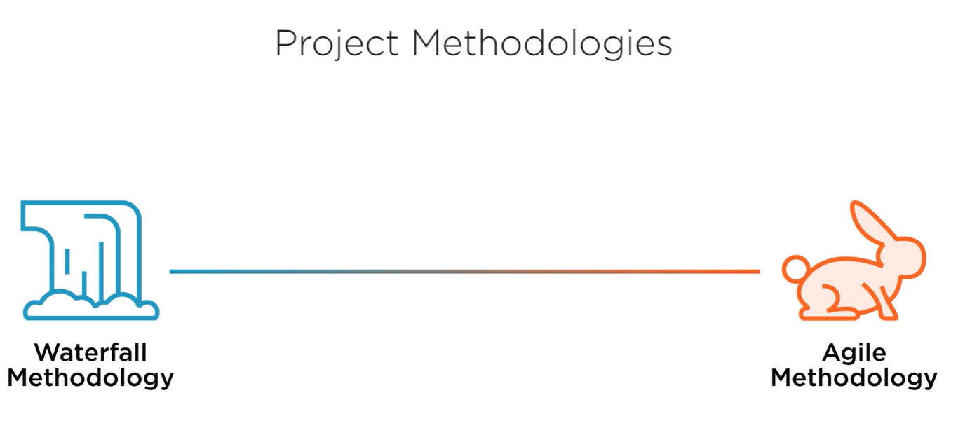
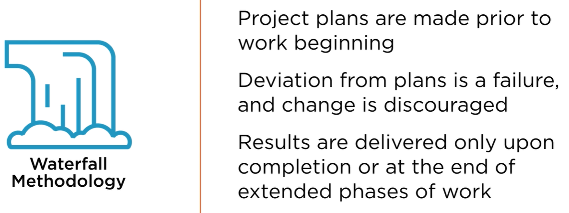
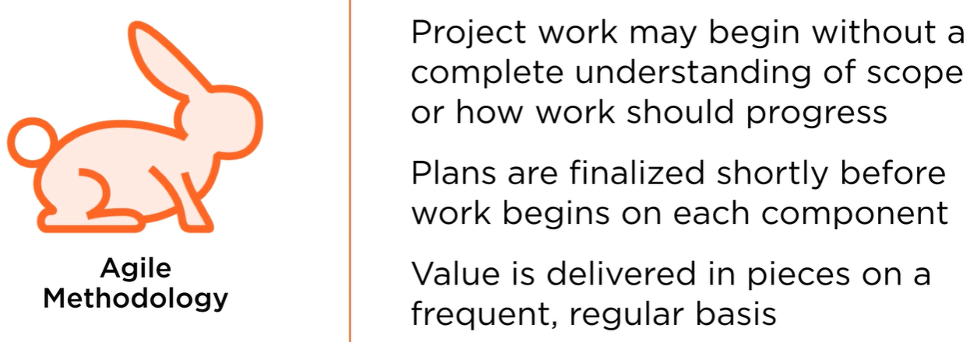
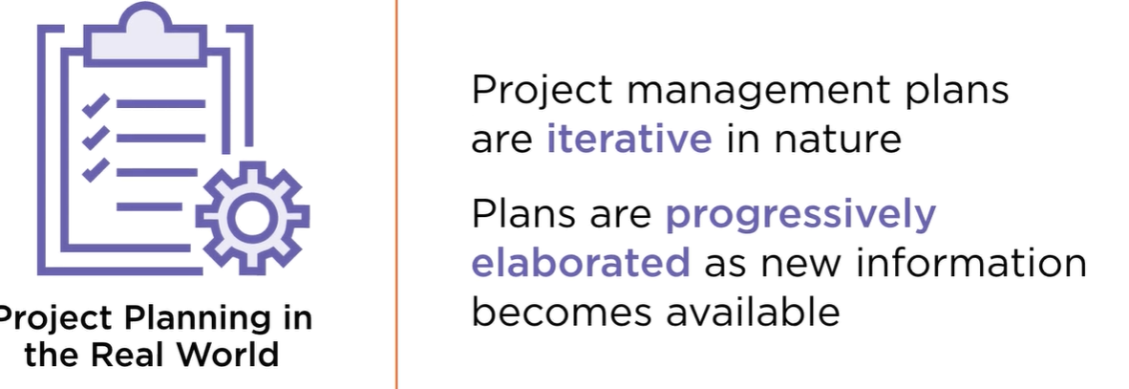
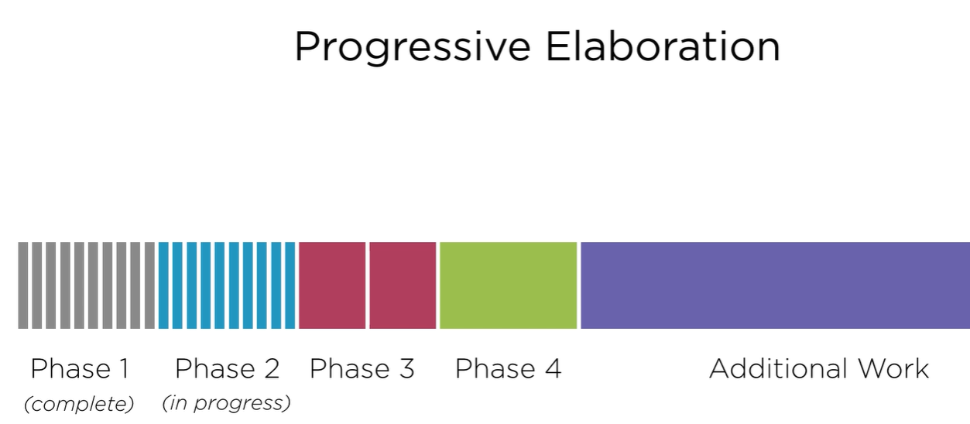
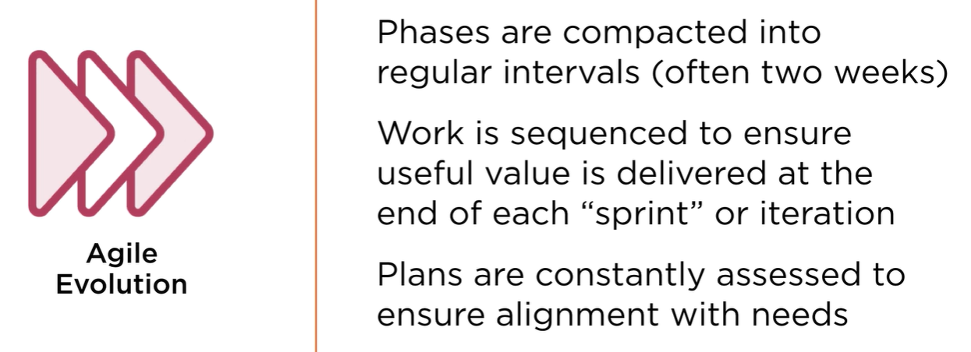

Among the core principles of an agile mindset,
perhaps standing above them all is simply deliver value early and often
to the customer. Rather than in traditional project environments where we
might not deliver anything to customers until the very end of our work or
deliver very slowly in phases over time, here our job is to rapidly
create and place incremental pieces of value into our customers hands as
quickly as practical.

This allows them to begin to get benefit right away.
And in many industries this is entirely possible,
just as it is within software development. Of course,
it might not be possible to deliver a house that's only
partially completed, but if we consider from a construction
mindset the idea that an entire neighborhood must be completed
before we could have anyone move in,
then we would consider that to be both crazy and not
particularly financially practical. Rather, by developing each
house and considering that to be something that can be delivered
to one of our customers at a time,
we're able to continue our work in an incremental fashion, and our
new residents can enjoy living in their new home while other homes in
the neighborhood continue to be built.

Embracing changing
requirements is just as important and is actually facilitated by the
incremental delivery of value.
After all, if we're delivering our value in pieces,
this allows stakeholders to provide us with feedback and for us to adjust our
future plans based on that feedback and any changes in the environment that
we've perceived in order to take that into account.
If we create all of our work and don't provide an
opportunity for this feedback and for the real-world use of
components of our solution in advance,
then inevitably we will find that things must be retooled because we've not
been able to make corrections to our plans along the way. Embracing our
changing requirements both based on this feedback,
as well as on the shifting preferences of our customers,
can help us to ensure that we not only are delivering value consistently,
but also delivering the highest levels of value possible.
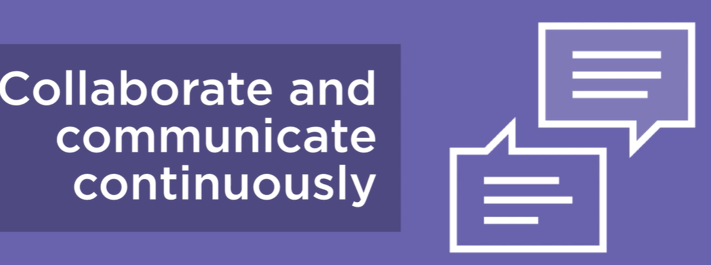
In order to accomplish this, collaborating and communicating
continuously with our customers, with our partners, and with other
members of the project team are all essential.
It's important for us to remain continuously coordinated in our efforts,
understanding what our customers value so that we can prioritize our
resources and our work and collaborating with each other to ensure that
we have an understanding of rapidly changing factors that might impact
the work that others are undertaking.
We should not seek to only have a meeting with the customer at
the very beginning of this process, eliciting information on
their requirements and preferences, and then providing them
with a solution at the end,
but rather, there should be a continuously verified
process where as we create value,
we are able to show it to customers and have a conversation about that, gauge
whether or not we've successfully understood their needs in the first place, or
if by using a portion of the product we produce,
customers are able to then better express the full extent of their
need to us moving forward.
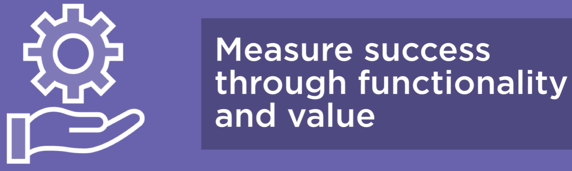
In measuring the success of our project
initiatives, we should look not at whether or not we stick to some
sort of arbitrary timeline or budget,
but rather how much functionality and value we are able to drive
as a team. Certainly, being able to stick to a budget and to a
schedule in a broader sense is valuable,
but it is not alone a measure of success.
We could come in ahead of schedule and under budget because we didn't
create a solution at all, and that wouldn't be very good.
In other cases,
we might be over budget, but deliver more than twice the anticipated value
because we have a better understanding of what our customers actually need,
and it was entirely worth being slightly over budget in order to create that
based on the continuous collaboration that we've maintained with our customers
who are very approving of this. Ensuring that we measure our success by the
value we deliver also helps to ensure that we remain committed to an obsession
in delivering this value to customers as often and as maximally as possible.
However,
that's not to say that our work should consist
entirely of a crunch time-style effort,
our hair constantly on fire as we move as quickly as possible to create
everything. Rather, a sustained pace is most important.
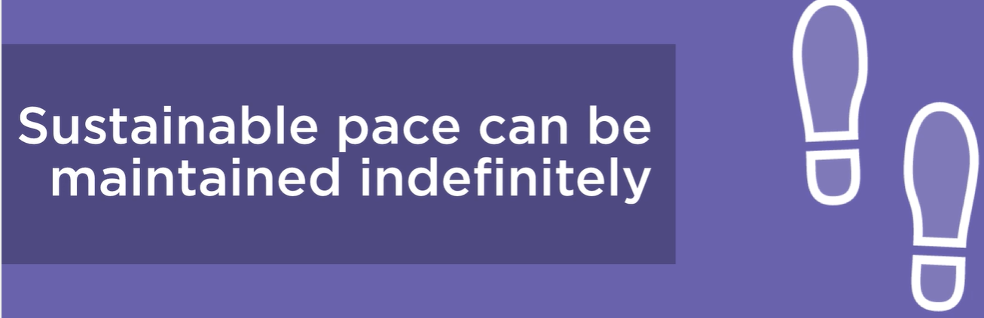
Being sustainable in
our approach means that we'll be able to continue to deliver on an
indefinite timespan at this same level of value.
This allows customers to begin to rely on the new level of value that we can
provide and the incremental delivery that we've committed to.
If we burn our team out and we later face delays or find
that the plans we've made no longer allow us to deliver
value as regularly to our customers, then we will have failed in our approach,
not only in the ways that we set expectations for our customers,
but also in empowering our customers to actually generate and
yield value from the work that we undertake.
It's critical not just for our own sanity,
but also for the true value that we can offer that we do
take a sustainable approach to our efforts.
The good news is by breaking up our efforts into regular,
intermittent time periods,
we should be able to gain a clearer idea of how much work we can
reasonably undertake within that two-week period as opposed to
planning six months in advance, running slightly behind schedule
for the first five months, and then seeking to make it all up in
that last few weeks. Next,
having a commitment to high quality actually enhances our agility.
Taking an inferior approach to quality might seem like it helps us in cutting
corners right now and saving a bit of time or resources,
but as we all know, inevitably,
this will lead to rework or to customer
dissatisfaction where, as you've guessed it,
we've not been able to deliver the expected level of value that we use as
our assessment tool. By focusing on getting it right in the first place and
by taking a sustainable approach to our work,
we can ensure that we create a solution that's not only as best
adapted to the customers' needs as possible,
but also durable and reliable in nature.

Next is one that may seem counterintuitive in some respects,
which is seeking to maximize the work that's not done.
However, if you think about it,
oftentimes the problems that we have in traditional project
environments have a lot to do with the work that we have done,
not the work that we haven't. It has to do with that work that either
must be redone because we have not been able to meet our quality goals
or work that we must expand onto our initial scope because the needs of
our customer have evolved and we were not able to properly incorporate
that into our planning,
meaning that we've wasted time on work that doesn't offer sufficient value.
By continuously asking ourselves is this worth our time,
will this specific action drive value, we can be much
more judicious in our approach,
helping us to remain more sustainable along the way and
also focusing exclusively on those tasks that directly tie
back to value for our customer.
Projects rely on more than one contributor in order to be successful, and no
master project manager alone can coordinate the efforts meticulously of every
stakeholder in order to arrive at a perfect finish.
Rather,
we must rely on the unique talents and perspectives that
everyone involved in this initiative have to offer.
This includes not only members of our project team, of course,
who will be responsible for helping to implement the solution,
but also the various stakeholders and decision makers whose perspectives
can help to shape the work that we're going to undertake.
This goes hand in hand with our next principle,
which is that team members must be more than simply cogs in a machine in
order for our efforts to be as successful as they can be.
We must be not only welcoming, but insistent on receiving feedback
from all of our team members and gaining their perspective such that
we can build organically toward the most optimal possible future
rather than following regimented processes alone that seek to tamp
down on the different perspectives and variances from which
innovations can emerge.
This also helps us to motivate our individual team members who we need
to rely on in order to accomplish these objectives.
Taking a humble approach as a project manager can also help us to see that
following a traditional organizational structure might not be the way to
deliver value in every sprint or iteration of our project work. Rather, by
allowing teams to self-organize on an organic sort of fashion, we can naturally
bring together the talents and viewpoints necessary in order to accomplish each
task that we've defined. Ensuring that these efforts for self-organization are
effective requires that we maintain communication between all parties involved,
and doing so is often best in a face-to-face capacity. Rather than simply
shooting off a quick text or email or even just relying on a phone call,
nothing can beat the synchronous direct approach of being able to speak
one person to another. In these sorts of environments,
we can rely not just on the words that are said,
but also on the body language of the individuals to learn
better what their true feelings might be.
Perhaps they have reservations about the plan that they're hesitant
to share because they don't want to hold work up,
but their perspective is very valuable, and it turns
out that without including it,
we would've done a significant amount of work that would
have been a waste of time. Ensuring that we can grab these
sorts of insights from each other,
both when it might be something that we might be hesitant to share in other
environments and when it might simply naturally come up through the
affordances of a conversation being able to evolve, are so important to being
able to deliver value on a continuing basis.
Finally,
we must seek to reflect and strive to continuously improve on our efforts.
Again, providing value on an incremental, regular basis,
such as every few weeks, provides such a natural opportunity for
this to occur, not only through reviews with customers where we can
show them what we've created and receive feedback that can help us
to tweak our ongoing plans,
but also in the retrospective efforts that we can have within our team,
understanding what went right,
what went wrong, and how we might seek to do our work differently.
moving forward. These retrospective sessions are not meant to simply
cast either blame or reward individual members,
but rather learn how the team as an overall unit can function better
moving forward. Each mistake is an opportunity for us to embrace new
knowledge and refine our approach so long as we have the humility to do
so and the enthusiasm for continuous improvement that project teams exemplify when most effective.

Conclusion
Let's take a moment to review.
Business analysis efforts are so vital to today's organizations because they
define the future of organizations and their initiatives.
We are the ones who help to chart the path forward,
understanding what our strategy should be to align with our values
and aspirations and to turn those ideas of the future into concrete
actions that can allow us to get there.
Envisioning this path to a desired future requires first
developing a deep understanding of the present.
This involves analyzing a variety of documents and data
sources that we have at our disposal,
as well as speaking to stakeholders directly, learning from their
perspective through elicitation sessions to gather a complete picture
of where we stand and where we'd like to go.
Agile analysts must conduct this work in a dynamic fashion,
continuing to learn more about the specifics of certain components or
parts of our present state over time such that we can develop and
define what requirements should look like based on that understanding
as our work continues to take place.
The agile mindset places collaboration and creation of functionality
above planning and processes, and we should as analysts as well. Rather
than focusing purely on following some sort of rote set of elicitation
sessions or sticking to a very specific schedule, we should adapt our
approach to what fits each challenge best rather than trying to use the
same tactics or techniques in every situation. Learning which
stakeholders we should speak with and how we can best gain information
from them,
what research we can undertake, when and how we define our
requirements, and so forth should all adapt to fit the approach
that best meets our project's needs now,
not just for any individual project overall,
but at this specific period in time. An obsessive focus on value allows agile
teams to operate more effectively and efficiently in high-change environments
where there might be large amounts of uncertainty or rapidly changing factors
such as the competitive landscape that force us to quickly continue defining
and redefining what our definition of success might look like as our work is
completed.
Conducting business analysis in an agile fashion requires a mixture of
both universal timeless business analysis techniques,
as well as specialized techniques that are uniquely suited to
agile environments where we must move quickly in defining and
implementing our solutions.
Key resources are helpful in developing these techniques and in preparing
for the IIBA-AAC certification, which can prove your knowledge and
proficiency when it comes to agile analysis. We'll begin by looking at two
of these key resources in our next module,
Agile and the Business Analysis Body of Kknowledge. I'll look forward to seeing you then
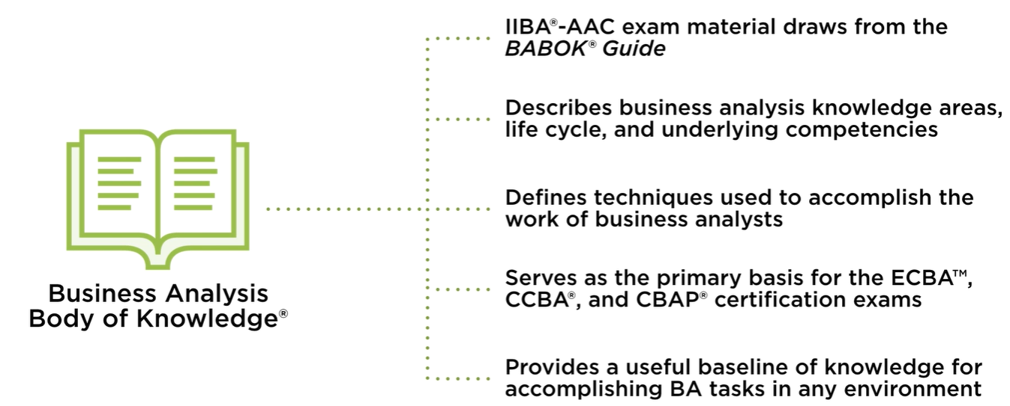
The Business Analysis Body of Knowledge, or BABOK Guide, is one of the central
resources from which the IIBA-AAC exam draws it's material.
This guide describes business analysis knowledge areas,
the lifecycle of business analysis, and many of the underlying competencies
that effective business analysts are able to exhibit.
It defines techniques that are used to accomplish the work of
business analysts in a variety of scenarios.
In addition to the IIBA-AAC exam,
the BABOK Guide also serves as the primary basis for other IIBA
certifications, including the ECBA, CCBA, and CBAP certification exams,
all of which have separate course series here at Pluralsight
that can help you in your preparation.
The BABOK Guide also provides a useful baseline of knowledge for
accomplishing business analysis tasks in any environment.
This includes those that are more predictive or waterfall in nature,
as well as the agile environments that we're focused on. In order to
do so, the BABOK Guide breaks down the work of business analysts into
a variety of knowledge areas.
This includes planning and monitoring,
elicitation and collaboration, requirements
lifecycle management, strategy analysis,
requirements analysis and design definition, as well as solution evaluation.
Let's take a closer look at each of these knowledge areas. When
it comes to planning and monitoring, this encompasses activities
that are related to the organization and coordination of our
work as business analysts.
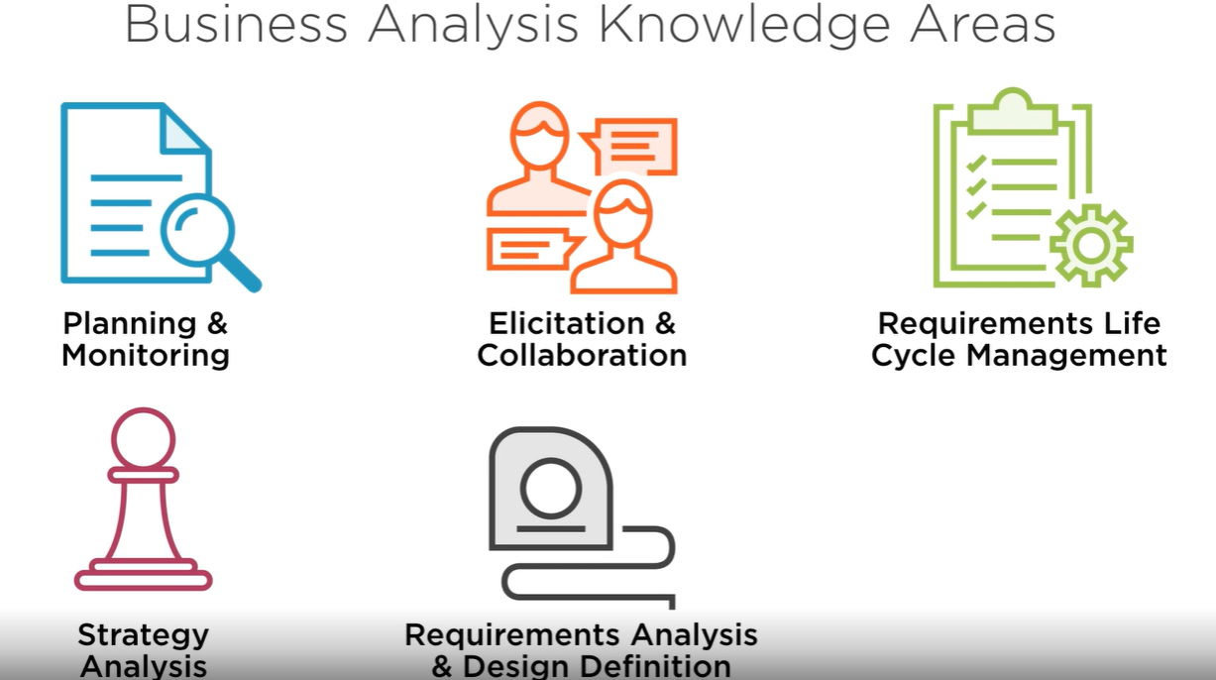
Some of the specific tasks included in this knowledge area
include planning our approach to business analysis.
How will we go about this entirely? Are we going to focus more
on data and information or on elicitation? When are we going
to conduct elicitation sessions?
How are we going to learn information?
How will we define out what our present state is and our plans for the future?
And what kind of project methodology might we anticipate working with such that
we can tailor our structure around that as well?
Planning stakeholder engagement, not only those that we might elicit
information from directly, but also those with whom our business
analysis efforts or the changes we might be proposing might have an
impact; panning business analysis governance where we ensure that our
approach is sound in nature,
that we're able to be objective in the way that we define a vision and
that we can ensure a rigorous approach to all of our efforts; planning
business analysis information management where we'll keep all of our
necessary data that we've been able to unearth through our analysis
efforts together; and identifying business analysis performance
improvements,
ways that we can continue to enhance our approach and
be more optimal moving forward.
The elicitation and collaboration knowledge area allows analysts to gather
information from stakeholders and other sources in order to define
requirements. To do this, we begin by preparing for elicitation, considering
what types of elicitation formats might work best, who should participate,
and how we might sequence all of these events.

Conducting elicitation itself
is also an obviously important portion of this knowledge area, as is being
able to confirm our elicitation results where we return to stakeholders after
elicitation sessions to confirm with them what we have heard and if that
lines up with what they believe that they have told us such that we can make
sure that we can benefit from their perspective effectively. Communicating
business analysis information falls into this category as well, as does
managing stakeholder collaboration more broadly both within and outside the
context of elicitation. From a requirements lifecycle management perspective,
visions are realized by completing various requirements that comprise these
solution components.
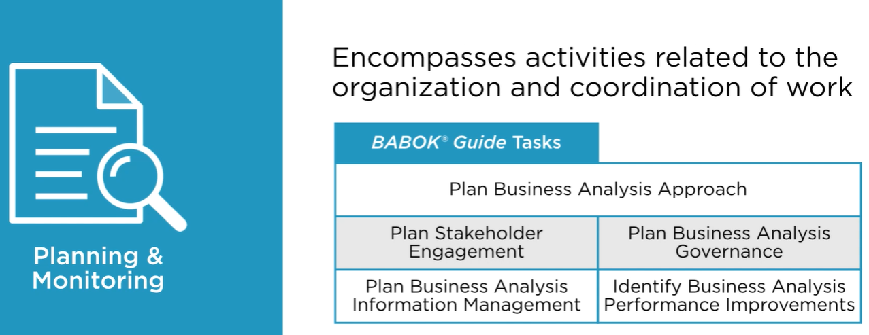
This means that we have to do things like trace our requirements to ensure
that we undertake the work necessary to meet needs and that every piece of
work that we do does indeed tie back to some sort of core objective.
Maintaining requirements must be done over time to accommodate for any changes
in either the underlying objectives or the priorities of when and what we
should be trying to accomplish,
which ties in directly with prioritizing our requirements. Assessing
requirements changes, as well as having some sort of approval
mechanism in place to make sure that we know which requirements and
which version of each requirement represent the work to be completed
is part of this process as well.
Strategic thinking from the strategy analysis knowledge area ensures solution
plans and requirements align with organizational objectives.
Some of our processes here include being able to analyze the current state
and define what we want that future state to look like and also assessing
risks that we might face, defining a strategy for our change to be undertaken
and generally considering the strategic factors at both an initiative and
organizational level that might come into play. Requirements and design
details must be thoughtfully specified in order for solutions to meet our
organizational goals.
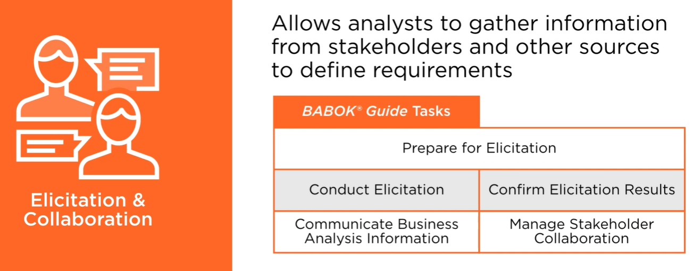
Tasks that are included within this knowledge area include specifying
and modeling our requirements, as well as verifying them and validating
them. Defining requirements architecture,
defining design options, and analyzing potential value, as
well as recommending solutions are the other tasks that
round out this knowledge area.
Finally, with solution evaluation,
we can ensure that our completed work aligns with
underlying needs and strategic drivers.
Within this knowledge area, we might seek to measure solution performance,
analyze our performance measures,
assess our solution limitations, as well as those that might be external
to the initiative, but still causing an impact, in addition to
recommending actions to increase solution value.
As you can see, a wide variety of tasks exist within
each of these knowledge areas,
helping us to understand the many dimensions of responsibility for business
analysts. In order to facilitate fulfilling each of these tasks, a variety of
business analysis techniques may be utilized for each BABOK Guide area. Deep
knowledge of each of these tasks and techniques is not necessary for the
IIBA-AAC certification itself; however,
developing a basic understanding and insight into how they relate to
Agile can certainly be of high value in being able to successfully
complete the exam and, more importantly,
improve your craft as a business analyst within agile environments.
The Agile Extension to the BABOK Guide indicates how each of the
techniques it mentions also might be mapped to agile initiatives
more specifically, giving you an idea of how to deploy each of
these different tools and techniques in a fashion that can help you to achieve your goals.
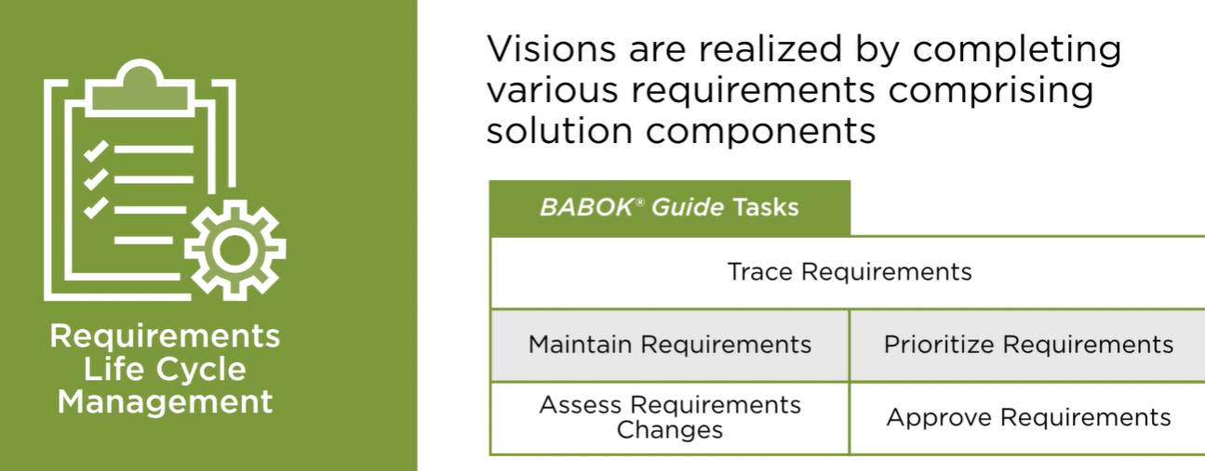

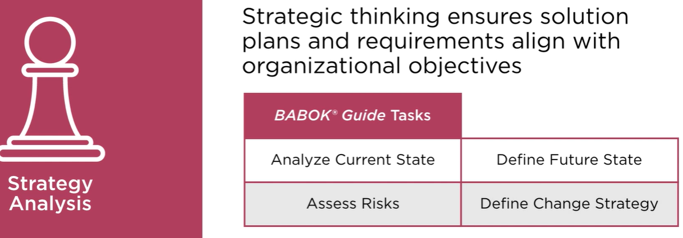
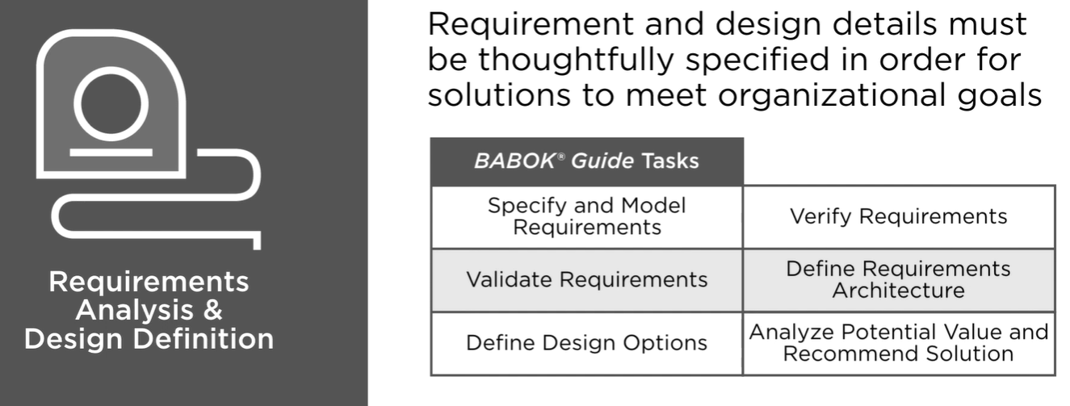

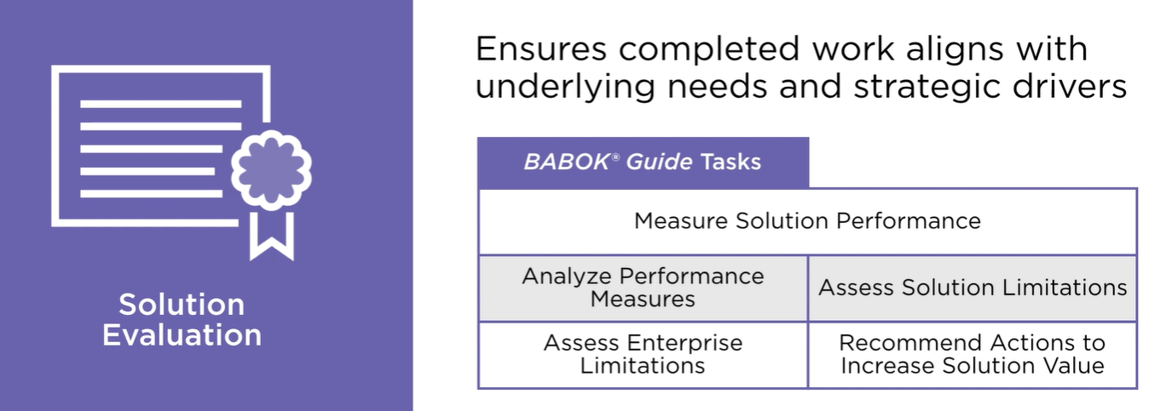

The BABOK Guide is an extraordinary underlying document for understanding
the profession of business analysis at a deeper level.
However,
the Agile extension to the BABOK Guide can offer unique
value for our point of discussion.
It expands on concepts from the underlying BABOK Guide to facilitate
better analysis in Agile environments. And it connects techniques from
the BABOK Guide to specific Agile workflows,
helping us understand how we can use these tools in a slightly different
capacity in order to reach goals within our Agile teams.
The Agile extension also describes additional techniques that are uniquely
useful in Agile environments, as well as introduces the business analysis
planning horizons, a way to think about our work within Agile that incorporates
our necessity to have plans and a vision for the future with our need to be able
to adapt swiftly to changing elements.
These include the strategy horizon, initiative horizon, and delivery horizon.
The strategy horizon is our broadest horizon,
allowing us to look at the impact that spans the entire organization,
focusing on the allocation of resources to many different initiatives,
not just the one in particular that we might be focused on.
This can involve looking months or even years into the future in order
to understand our broader organizational goals and how our more
specific efforts today might align with them.
This leads us to the initiative horizon,
a middle space closer to the ground than what our strategy horizon might be,
but not quite all the way down to the work that we're accomplishing today.
Our initiative horizon is focused on our initiative,
our team, or a specific goal that we might be trying to accomplish.
It may involve collaborating with teams that work
independently, or together with one another, in order to
accomplish a variety of different tasks.
This is certainly true in many project teams,
where we split up into subgroups in order to accomplish specific
objectives or might work with third party partners or vendors in order
to accomplish certain portions of our work.
This has a tighter focus than the strategy horizon, but a broader
focus than our third horizon, that of delivery,
which focuses on execution of defined work and on
creating value for the customer.
The delivery horizon prioritizes helping teams break down, deliver,
test, and learn from work that they undertake.
Our focus here is limited to the sprint or iteration that is presently underway.
We already know what we want to accomplish.
We focus here on what must be done. Within each of these horizons, you're
expected to have a certain level of competency in preparing for the IIBA-AAC
certification. From a strategy horizon perspective,
this includes basic knowledge related to defining the
scope of minimum viable products,
participating in stand ups, and identification and analysis of scenarios.
You should be able to also understand the importance of
identifying capabilities and new product backlog items. From
an initiative horizon perspective,
you should understand how to identify solution options,
components, and features, as well as how to estimate and
prioritize feature development. You should be able to follow
rules that are related to how scope is defined,
how to elaborate on feature details,
how to review and update component definitions, and how to review
outcomes and update scope for future releases. As might be expected,
the delivery horizon has the most items that we should keep in mind.
From a basic knowledge perspective,
you should understand how to estimate and size backlog items,
how to reassess items as factors merit, and what acceptance criteria
and the definition of done represent for our work.
You should understand how to utilize the backlog and
user stories to manage your work, develop high fidelity models,
prioritize and elaborate on user stories in the backlog, as
well as conduct reviews and retrospectives.
Finally,
you should also be able to follow rules related to creating and
elaborating user stories to add to the backlog,
identify and write scenarios and specifications, and determine
if work is ready for release to the customer.
As you can see, most of the things here are fairly introductory in
nature, and you are not expected to have fully mastered many of these
concepts in order to successfully complete the IIBA-AAC certification.
Rather, by having these introductory fundamental levels of knowledge in
each of these categories,
you can be prepared not only for the exam, but also to begin improving your
craft and earning that mastery over these various subject areas that allow you to perform well as an effective business analyst.
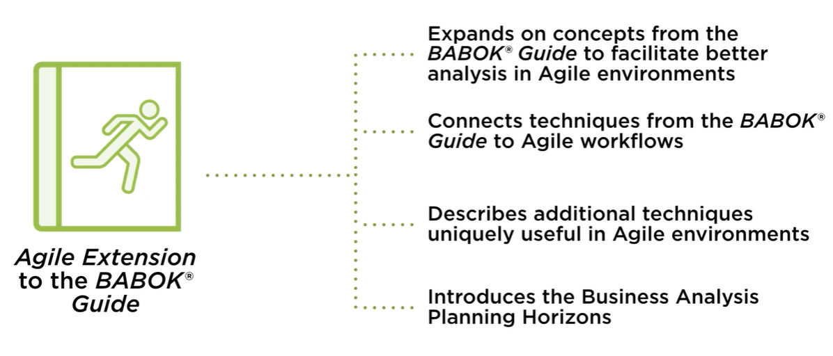
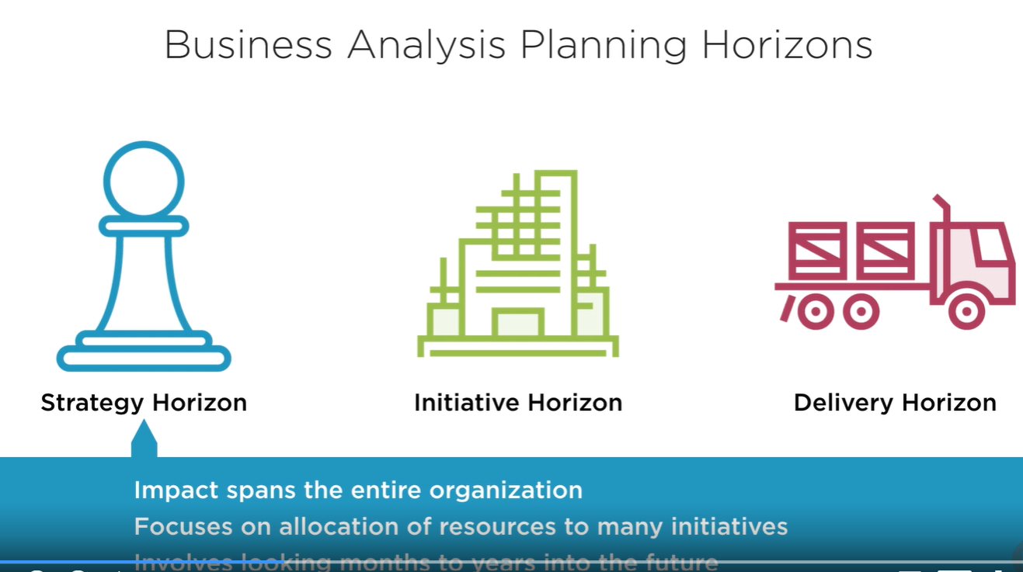

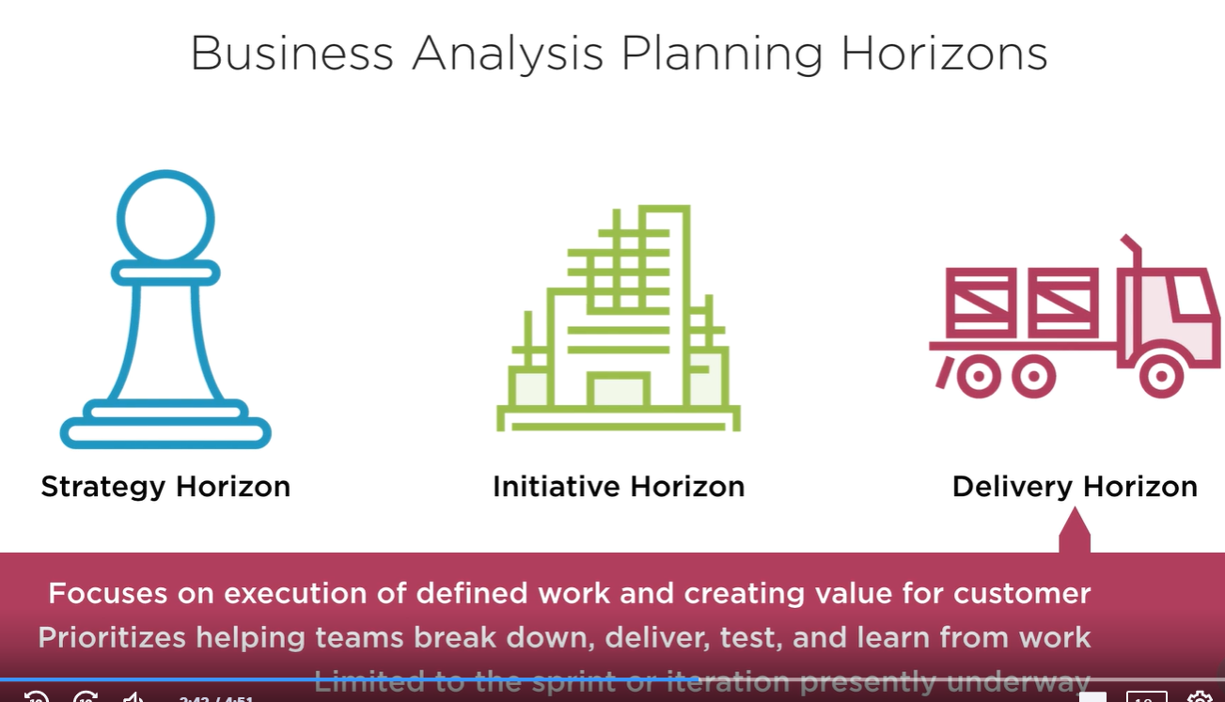

In addition to the BABOK guide and the Agile extension of the BABOK guide,
another tool that can be useful for us is the
Business Analysis Core Concept Model,
a framework for understanding the role and value of
business analysis efforts to organizations.
The Business Analysis Core Concept Model is comprised of six components
that are equally fundamental to successful analysis.
The BABOK guide and the Agile Extension tasks consistently
tie back to each of these core concepts.
First among these is change. After all,
improvement is impossible without undertaking change, and the focus of
so much of our business analysis efforts is on defining what change
should be and helping to allow change to occur.
Business analysis ensures that changes are deliberate,
justifiable, and controlled in nature, that we are
intentional with the change that we bring,
choosing consciously when we wish to evolve the way that we presently might
accomplish something, in order to reach some sort of new goal, and also being
very conscious for when we wish to keep things the same. Ensuring change is
intentional is key to determining if it's merited and if it has the sort of
success criteria that we might anticipate when we first proposed that the
change might be beneficial.
Next is the need perspective. Change, after all,
is driven by a set of underlying needs or opportunities that we
identify. Developing an understanding of these needs allows analysts to
propose initiatives that can help to meet them.
Change itself can also generate additional needs that
must be identified and addressed,
especially those that might be relatively temporary in nature, related to the
change effort itself, requiring some sort of accommodation or other temporary
fix in order to facilitate the development and deployment of the change
itself. Solutions come next. After all, needs are met through solutions that
comprise a variety of changes.
Solutions may meet needs directly, or they may empower
stakeholders to meet needs themselves,
providing them with a toolkit necessary for them to succeed.
Stakeholders then our our next element to consider. Stakeholders
include individuals and groups that may impact, be impacted by, or
perceive themselves as being related to changes, needs, or solutions
in their implementation.
This is a broad definition by intention.
This includes not just those who we might think are directly
involved in or impacted by the change of some sort,
but also those who feel that they themselves might be
impacted, even if we might disagree.
This is why it's so important to be expansive in our
identification of stakeholders,
considering from their perspective, how they might perceive a
change or an initiative is affecting them, so that we can
effectively manage that relationship,
elicit valuable information from them, and ensure that their
perspective is incorporated into our holistic plans.
It's critical to defining needs,
determining changes, and designing solutions that we
not only speak with our stakeholders,
but also, more fundamentally, know who they are.
Value comes next. Value may be measured in a variety of
fashions and be either tangible or intangible in nature.
In the cases of tangible value,
we can often find ways to convert that into some sort of
monetary metric. It might be as simple as a direct cost
savings where no conversion is necessary,
but if we create a change that allows us to deliver a product
more quickly to a customer, or process more items on a production
line within the same amount of time,
we can convert the new revenue that we might be able to recognize from
those improvements into some sort of monetary fashion for comparison and
analysis. Intangible value is also of critical importance and many
successful initiatives might focus entirely on generating new and tangible
value and not on tangible value at all.
Different measures of this intangible value can include increases in
morale for either team members or organization employees, new skills
being developed within the organization,
increasing our reputation as a business, or for a team internally,
as well as bettering our strategic footing as compared to the competition,
which could allow for future monetary gains, and much more. Value is often
best assessed from a relative perspective,
such that we can judge one action versus another, or the cost of taking
action versus the cost of not taking action at all.
Remember, even choosing to do nothing is itself a choice, and so in every
comparison, we should consider what would happen if the present reality were to
continue to persist into the future, as opposed to a number of the different
alternatives for action that we might generate.
Finally,
the contextual perspective includes all environmental factors that
are relevant to changes under consideration.
Such factors influencing business analysis efforts could
include the competitive landscape, cultural factors,
demographics, regulatory factors, the state of technology, and much more.
These could also include additional items,
such as our present technological advancement within the
organization, or our level of proficiency in undertaking the
kind of changes that we might propose.
It could also include the risk tolerance and threshold of the
organization, as well as whether or not we simply have the resource
means necessary to implement a solution,
even if we've envisioned it and have strong support.
These factors must be considered as part of our broader look at business analysis from each of these important perspectives.
Autoscroll
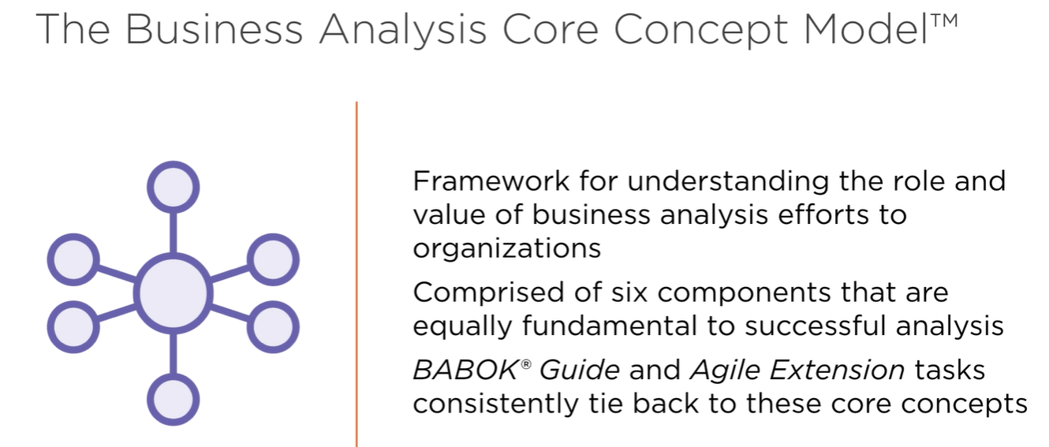
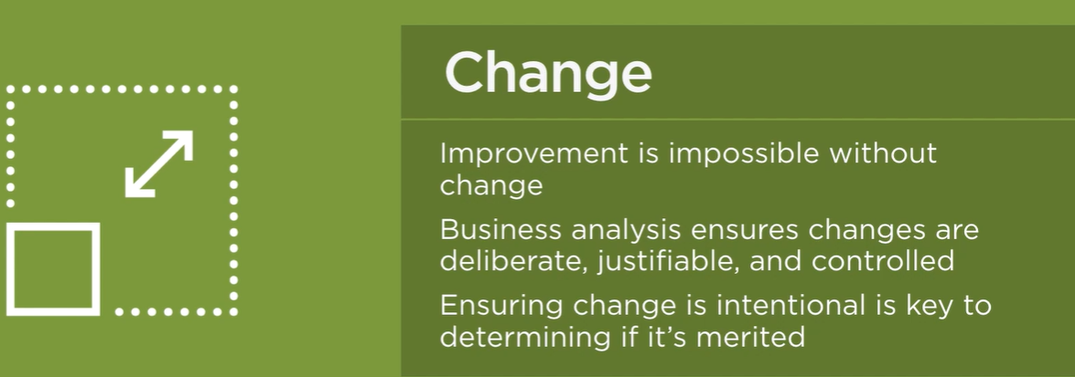
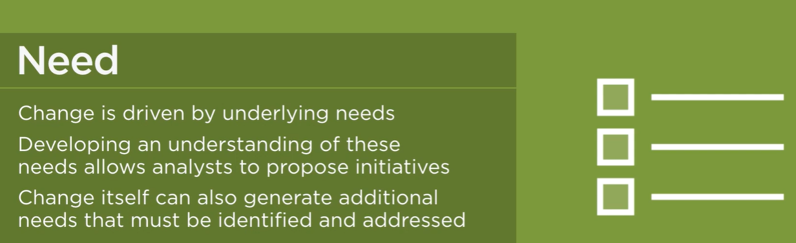
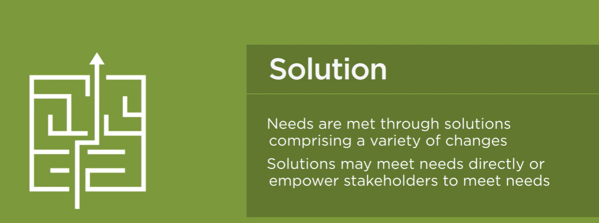
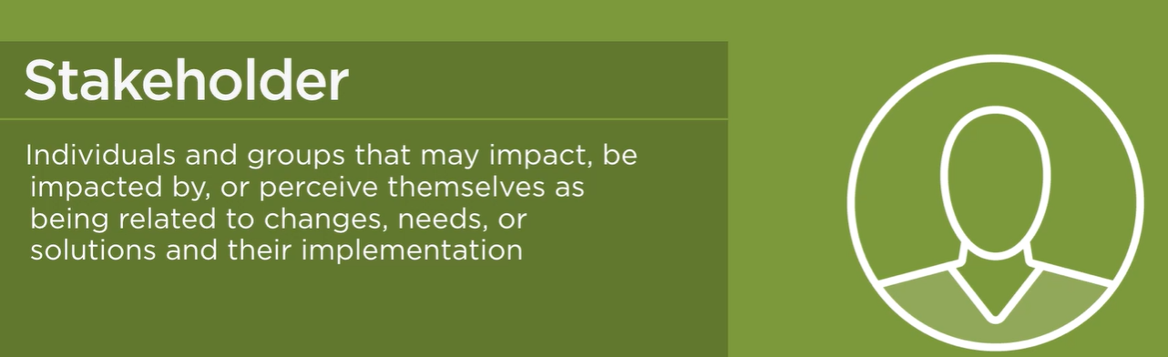
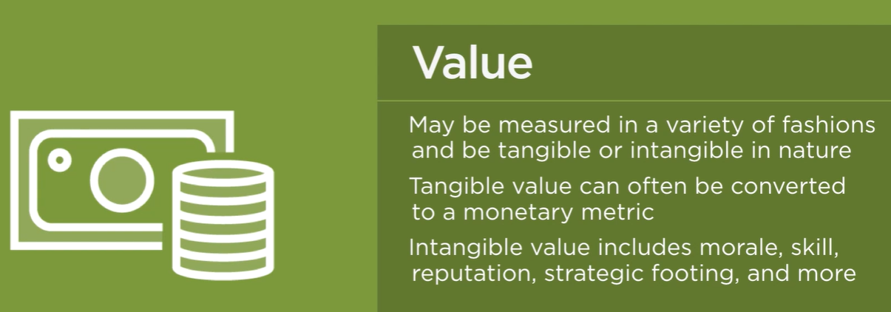
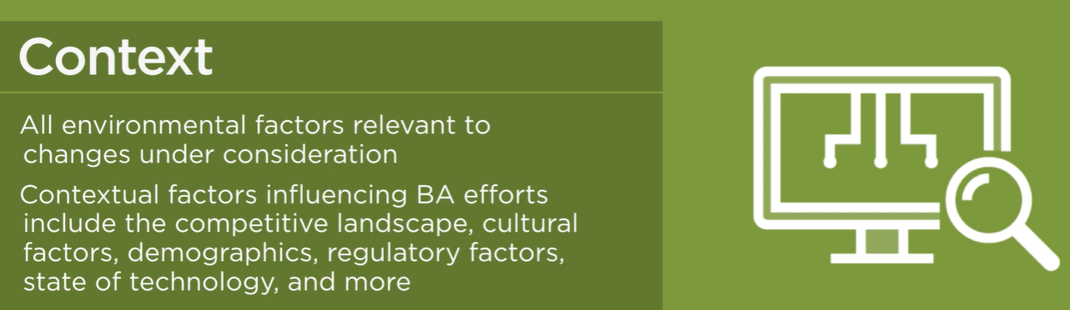

I find business analysis to be one of the most exciting and
dynamic areas in many organizations today,
given the extraordinary impact that you can have on
envisioning the future for your organization.
This is especially true in Agile organizations where things are moving
quickly and there's been a commitment to change.
And so, earning a certification like the IIBA-AAC that demonstrates
your commitment to this field can be very valuable.
The AAC certification, or Agile Business Analysis
certification, is offered by IIBA,
which is short for the International Institute of Business Analysis,
the most respected body focused on nurturing the
business analysis profession globally.
The IIBA-AAC may be earned independently from or in
conjunction with other more well-known IIBA certifications,
including the ECBA, CCBA, and CBAP.
And, thanks to the unique and specialized nature of this certification,
it can be helpful in earning business analysis
positions working with Agile teams,
showing that you have the unique skills, and just as importantly,
the specialized focus necessary to succeed as an Agile business analyst.
Some of the benefits of Agile analysis more broadly include being able to manage
changing priorities effectively, maintain alignment between implementation and
customer from beginning to end of an initiative,
get to market faster and deliver value more often, increase team flexibility
and productivity, and adapt to changing environmental factors effectively.
Hiring managers and other decision makers know that those who've placed an
emphasis on learning more about Agile are the ones who will be willing to try
new things and be committed to the changes necessary for today's rapidly
moving organizations.
As part of studying for the IIBA-AAC,
you'll develop a skillset to succeed as an analyst in Agile environments.
Hopefully this course is already helping you on that journey.
You'll be able to showcase your ability to perform effectively as
an analyst regardless of initiative methodology, comparing and
contrasting the ways that you might use certain techniques in a
more traditional, predictive,
waterfall style project environment versus those that are more Agile in nature
and the unique techniques that might come into play there. You'll gain an
understanding of current trends and best practices that can serve you well as
organizations continue to evolve toward a more Agile approach, and you can
augment existing certifications while continuing your education if you happen
to already hold an ECBA, CCBA, or CBAP. The AAC can be a great accompaniment
to any of these, showcasing not only your more general knowledge regarding
business analysis, but also your new specialized focus in the Agile arena.
The good news is there are no firm prerequisites for work
experience or training for the IIBA-AAC exam,
making it much easier to apply for than several of the other
certifications offered by IIBA that tend to come with more
extensive requirements regarding training and education, as well as
work experience that must be cataloged.
However, in order to succeed with earning this certification,
there is an expectation that you have at least 2-3 years of
experience applying an Agile mindset to business analysis.
This doesn't necessarily mean that you have to have worked
with an Agile team in the past or served in a business
analysis position within that Agile team,
but rather either have used an Agile mindset in the way that you've
conducted business analysis or otherwise have exposure to Agile teams such
that you have a familiarity with how they operate.
You should also be able to effectively analyze challenges at the
three different horizons discussed earlier,
those being the strategy, initiative, and delivery horizons. With a
bit of study and an appreciation of the unique value that business
analysis can offer to Agile environments, you'll be well on your way to earning this certification.


